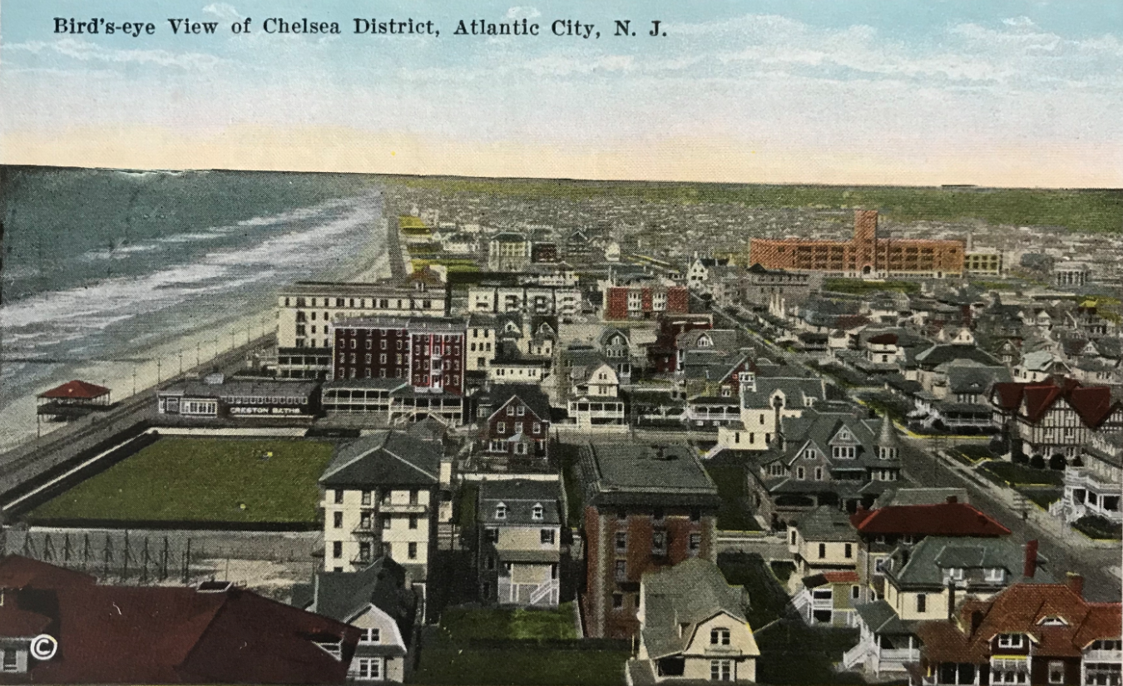
Chelsea Neighborhood Plan 2030
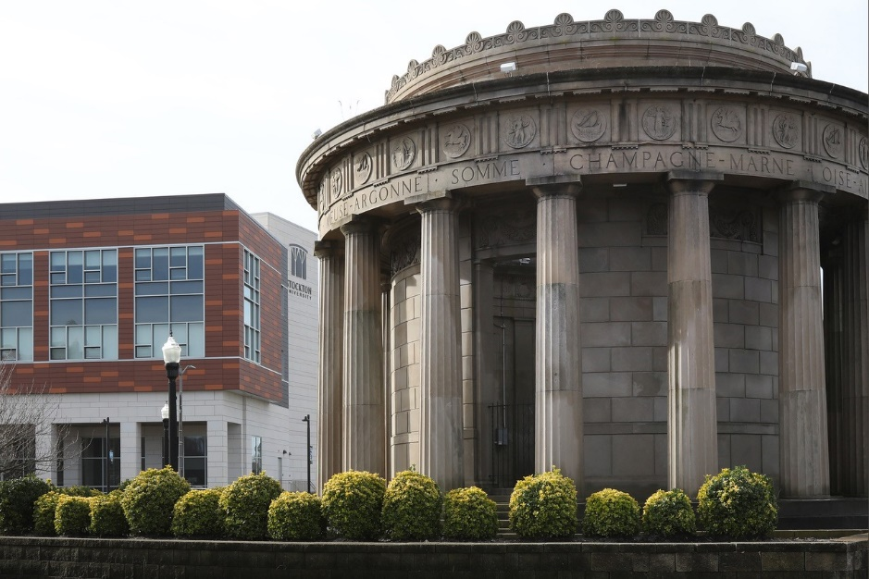
Submitted to New Jersey Department of Community Affairs on July 13, 2020
Table of Contents
Section 1: Cover Page 4
FORM NP-1: COVER PAGE FOR SUBMISSION OF A NEIGHBORHOOD PLAN 4
Section 2: Executive Summary 6
Section 3: Organization Information 8
A. Organizational Profile 8
B. Financial Resources 8
C. Community Involvement 8
FORM NP-2: ORGANIZATION PROFILE - ACDEVCO 11
FORM NP-2: ORGANIZATION PROFILE – Chelsea EDC 16
Section 4: Organizational Capacity and Experience 22
A. Organizational Capacity 22
B. Current Activities 23
C. Development and Service Delivery Capacity 24
D. Capacity of Partners 25
Section 5: Neighborhood Description and Statement of Need 27
A. Neighborhood Description 27
B. Conditions and Need for Revitalization 30
People 30
Income 31
Education 31
Housing 31
Health 32
C. Evidence of Neighborhood Distress 32
D. Photographs of Neighborhood Conditions 32
E. Description of Other Plans 34
F. Municipal Support Letter 37
Section 6: Neighborhood Assets & Involvement 38
A. Neighborhood Assets 38
Community Assets 38
Regional Assets 41
Municipal Revitalization Priorities 42
Recent Investment 42
B. Neighborhood Involvement 43
Community Organization Effectiveness 43
Community Support and Engagement 43
Section 7: Proposed Vision, Strategies, Activities & Outcomes 45
A. Vision Statement 45
B. Strategies 45
Focus Area #1: Strengthen Community 45
Focus Area #2: Safety & Resident Wellness 47
Focus Area #3: Youth & Recreation 49
Focus Area #4: Housing 50
Focus Area #5: Economic Development 52
C. NRTC Investment as a Catalyst 53
D. Projected Strategies, Activities, and Outcomes – Form NP-3 55
E. Project Activities Budget & Timetable – Form NP-4 62
Section 8: Participatory Planning Process 72
Steering Committee 72
Neighborhood Survey 73
Community Meetings 73
Public Officials 75
Association & Community Groups 75
Internet & Social Media 75
Direct Outreach 75
Review of the Draft Plan 76
Section 9: Attachments 77

Section 1: Cover Page

FORM NP-1: COVER PAGE FOR SUBMISSION OF A NEIGHBORHOOD PLAN

Neighborhood: |  |  | Chelsea |  |  |  |  |  |  |  | NJ Legislative District: |  |  |  |  |  |  |  |  | 2nd
Eligible Municipality: |  |  |  | Atlantic City |  |  |  |  |  |  | Mayor: |  |  |  | Marty Small
Name of Applicant Organization: |  |  |  |  |  |  |  |  | Atlantic City Development Corporation (ACDEVCO)
Name of CEO/Executive Director: |  |  |  |  |  |  |  | Christopher J. Paladino
Address: |  | PO Box 8200
City: | Atlantic City |  |  |  |  |  |  |  |  |  | State: |  |  | NJ |  |  |  |  | Zip Code: |  | 08404
NJ Charities Registration Number: |  |  |  |  |  |  | CH 3963200
Contact Person for this Application: |  |  |  |  |  | Elizabeth A. Terenik
Phone: |  | 609-425-9207 |  |  | E-Mail: |  |  |  |  | ETerenik@acdevco.org
Cellphone (optional): |  | (same)
What is the time period for this Neighborhood Plan?  (may not exceed Ten (10) years) |  |  |  |  |  |  |  |  |  |  |  | 10 years
Did you partner with another organization to develop the Neighborhood Plan? |  |  |  |  |  |  |  |  |  |  |  |  | YES |  |  |  | x | (if YES, complete NP-1 Page 2)
 |  |  |  |  |  |  |  |  |  |  |  |  | NO

Certification: To the best of my knowledge and belief, the data in this application are true and correct. The governing body of the applicant has duly authorized the document.

Jon Hanson | Board Chairman
Name | Title
(hard copy signed) | 7/10/2020
Signature of Board Chairperson | Date

FORM NP-1, page 2: PARTNERING ORGANIZATION INFORMATION

Please provide the following information for each organization with which you partnered in developing the Neighborhood Plan. Copy and attach additional sheets if necessary.

Name of Partnering Organization: |  |  |  | Chelsea Economic Development Corporation
Contact Person (including title): |  |  |  | Ken Calemmo, Board Secretary
Contact Person’s Address: |  |  | 1125 Atlantic Avenue
City: | Atlantic City |  |  | State: | NJ | Zip Code: |  |  | 08401
Phone: |  | 609-344-3161 |  | Cellphone (optional): | 609-287-1716
E-Mail: | kcalemmo@cooperlevenson.com
Briefly describe the role of the partnering organization in developing the Neighborhood Plan:

Chelsea EDC served as the on-the-ground organization in the neighborhood that engaged with the community through public meetings, projects, and its board members, website, and social media sites.

Section 2: Executive Summary

The Chelsea neighborhood in Atlantic City is the area of focus for the NRTC Plan. It is a 0.75 square mile area from Annapolis Avenue to Texas Avenue and from the Beach to the Bay - its boundaries follow census tracts 3, 4, and 5. The neighborhood is home to 10,433 residents. Chelsea’s greatest assets are its diversity of people, businesses and institutions, as well as its pristine beach and expansive bay access.
Due mainly to Atlantic City’s economy of tourism and gaming, and associated low wages, the City has experienced limited economic opportunity in recent decades. This lack of economic diversity has exacerbated longstanding and deep rooted challenges such as social problems and inequities, blight, low educational levels, crime, and other negative indicators.
Property taxes have also risen dramatically in recent years, starting with the Great Recession that began in 2008, and sharpening with the steep decline of the casino industry in 2014. Adding to these challenges, the effects of COVID-19 in 2020, have been devastating for Atlantic City. Casino hotels, the primary employer of City residents, have just reopened on an extremely limited basis after three and a half months of closure. Many casino workers had difficulty receiving unemployment payments due to the system being overwhelmed, going months without any source of income. The Brookings Institute reports the Atlantic City region as likely the third hardest hit in the country due to its reliance on tourism and hospitality. This further exemplifies the need to grow other industries, while concurrently preparing the residents for better jobs.
While ACDEVCO’s 2018 Gateway project, consisting of Stockton University’s Atlantic City Campus and South Jersey Gas Headquarters, has had a significant positive impact on the neighborhood and provides a solid foundation on which to build, the challenges still exist, and are the reason for this plan and intended actions.
The foundation of the Chelsea Neighborhood Plan is inclusive of every person, business, and organization in Chelsea. The strategies in this report will strengthen community, increase economic opportunities, and provide for better housing.
This plan is the culmination of nearly a year of projects, resident engagement and public input, including meetings, surveys, focus groups, and research. Hundreds of Chelsea community members expressed their opinions, suggested impactful strategies, and overwhelmingly offered to help put these ideas into action.
ACDEVCO, the applicant organization, led the transformative redevelopment of Chelsea's Gateway Area, which opened in fall 2018. The $220M project was designed to help meet the educational and redevelopment needs of Atlantic City. Building on its experience with the Gateway project, over the past year ACDEVCO partnered with Chelsea EDC and other local organizations to undertake a series of neighborhood projects to expand economic opportunity and improve the quality of life as the planning process got underway. These projects were invaluable in understanding the business community’s needs, the housing conditions, and the capacity of the many organizations that will help carry out the proposed strategies.
Over the next 10 years, ACDEVCO will work to implement a series of strategies to chart a path for a better future. Seeking to foster community, increase economic opportunities, and provide better housing for all Chelsea residents, this plan has five (5) distinct focus areas:
Strengthening Community: Chelsea has an incredible diversity of cultures. Engaging residents, promoting the arts, and fostering the leadership capacity of Chelsea residents are paramount for success.
Safety & Resident Wellness: Residents and stakeholders continually brought up issues that relate to the overall wellness of the community. Working to improve neighborhood safety, pedestrian and cyclist infrastructure, and healthy lifestyles pays dividends long into the future.
Youth & Recreation: Improvements are needed to existing parks and recreational facilities as well as programming for Neighborhood youth. The Chelsea Neighborhood will benefit from the activation of O’Donnell Park and the establishment of quality recreational programming for youth.
Housing: Housing needs were very clear – better quality housing priced within residents means. Supporting individuals looking to purchase a home, improving the quality of the existing housing stock, and promoting the overall resilience and beautification of Neighborhood properties.
Economic Development: The strategies in this section fall into two categories – supporting the businesses in the neighborhood; and providing resources to the residents to earn a living wage with opportunity for advancement. Diversifying the Neighborhood economy, supporting existing businesses, and preparing workers for good, local jobs will lead to a vibrant Chelsea.

Section 3: Organization Information

Organizational Profile
Atlantic City Development Corporation (ACDEVCO) is a non-profit redevelopment company with a mission to promote economic development in Atlantic City. ACDEVCO has fostered public-private partnerships based on the public policy goals of Atlantic City, Atlantic County, the State of New Jersey, and corporate and institutional partners in the region. ACDEVCO’s $220 million Gateway project in the Chelsea neighborhood, opened in 2018, expanded economic and educational opportunities, and redeveloped seven acres of blighted land.
See NP-2 forms for ACDEVCO and Chelsea EDC attached.

Financial Resources
ACDEVCO has financial resources represented by an equity investment in the AC Gateway project valued at $2.1 million, as well as land valued at $6,726,000. Revenue from leases are valued at $233,000 for 2020. The return on equity investment in the project paid annually is $252,000. ACDEVCO began 2020 with a cash balance of $317,031.
The 2020 operating budget anticipated revenue from commencement of the Gateway Phase 2 project in partnership with Stockton University. The amount anticipated is $2.5 million from sale of land, as well as reimbursement of costs expended in 2019 in the amount of $1.8 million. The project, while fully permitted and scheduled for a financial closing in November 2020, has been put on hold due to the COVID-19 state of emergency.
ACDEVCO has not been the recipient of any grant from the Department of Community Affairs in the past 5 years.

Community Involvement
ACDEVCO’s principal involvement in Chelsea has been the development of the Gateway project and support for the Chelsea EDC. The Gateway project met several neighborhood needs, including:
- Revitalization of property that had been vacant and blighted for over 30 years
- Access to educational opportunities
- Hundreds of construction and long term jobs
- Medical/urgent care facility
- Improved infrastructure
Throughout the Gateway planning and construction process, ACDEVCO met with government officials, neighborhood residents, businesses and community leaders. It was through this engagement that ACDEVCO established itself as an organization that goes above and beyond expectations when executing a project. For example, additional infrastructure work beyond that required was completed for the City; beneficial parking arrangements were provided to surrounding neighbors; and the organization has contributed thousands of dollars to community organizations such as the Atlantic City NAACP, the Atlantic City Arts Foundation, William J. Hughes Center for Public Policy at Stockton University, Friends in Action, and the Hope Foundation. ACDEVCO is also the sole sponsor of the Press of Atlantic City’s Annual Young Leaders Awards.
In addition, local hiring programs were established as part of the project for both construction workers and subcontractors. A local organization, Friends in Action, was engaged to identify and train local workers.
MudGirls Studio, an Atlantic City based non-profit organization that provides economic opportunity to disadvantaged women by teaching them to create functional ceramic art and architectural tiles, successfully completed three (3) projects for ACDEVCO for the South Jersey Gas Headquarters Building, Stockton University Academic Building, and Stockton University Residential Building.
Additionally, ACDEVCO has hired and trained local interns on project management and neighborhood planning.
More recently, ACDEVCO provided staffing and programming costs for projects partnering with Chelsea EDC starting in 2019 to present. ACDEVCO supported a series of neighborhood based economic development projects to promote homeownership, build community, and support small business. In the summer and fall of 2019, ACDEVCO, in partnership with Chelsea EDC, funded jitney tours and information sessions for neighborhood workers from Stockton, South Jersey Gas and AtlantiCare, as well as the general public, to learn about properties for sale and the home buyer incentives available. In fall 2019, ACDEVCO hired ten local restaurants to provide food for a neighborhood-wide event seeking to build connections among Stockton students and neighborhood small businesses. In February 2020, ACDEVCO coordinated a Jacob Lawrence event at the Sovereign Avenue School in Chelsea, and provided art supplies to 24 third to sixth graders to learn about the artist and recreate one of his most famous paintings.
During the COVID-19 pandemic, ACDEVCO worked with neighborhood cultural organizations to identify families in need of support, and hired three neighborhood restaurants (Chinese and Latinx) and one corner store (Bangladeshi) to provide cooked food and meal supplies to over 100 families. In June 2020, ACDEVCO funded a billboard congratulating the neighborhood 8th grade graduates. Also in response to the pandemic, ACDEVCO is assisting small restaurants to obtain outdoor seating approvals from the City since indoor dining is not allowed. Currently, ACDEVCO is organizing meetings among tech companies, economic development agencies, youth programming organizations, and others to establish career pathways in non-tourism jobs.
Through the public input process for this plan, which has included meetings, focus groups, steering committee engagement, press releases, and website and social media accounts (Facebook, Twitter, Instagram), Chelsea EDC has communicated with an estimated 500+ community members. The email marketing program has 300 recipients, with more people signing up regularly though the website.
ACDEVCO and Chelsea EDC have established informal relationships with the following neighborhood organizations and institutions, with the intent to create formal partnerships as part of the implementation of the Plan’s strategies:
- Chelsea Neighborhood Association
- Boys and Girls Club of Atlantic City
- Our Lady Star of the Sea/St. Monica’s Parish
- Hispanic Association of Atlantic County
- Stockton University
- South Jersey Gas
- AtlantiCare
- Tropicana Hotel and Casino
Through these and other hyper-localized events, ACDEVCO, along with Chelsea EDC, recognizes and helps realize the economic potential of the neighborhood. ACDEVCO has proven its ability to complete a significant project and has the capacity to implement the Chelsea Neighborhood Plan, with the assistance of its partner, Chelsea Economic Development Corporation.

FORM NP-2: ORGANIZATION PROFILE - ACDEVCO

A. AGENCY INFORMATION
What was the organization’s date of incorporation? |  |  |  |  | February 24, 2015
What was the original purpose for which the organization was formed?
promote economic development in Atlantic City
What is the organization’s current mission statement?
promote economic development in Atlantic City
Is the organization in “Good Standing” with the NJ Department of State?
YES | X | NO
When did the organization file its current N.J. Charitable Registration and Investigation Act Report (CRI-300R)?
Date: |  | 12/17/19
Documents to be submitted as Attachment(s):
- ”Certificate of Good Standing” certificate from State of New Jersey
- Copy of current NJ CRI-300R form
B. BOARD OF DIRECTORS INFORMATION
Board Chairperson: |  | Jon Hanson
 | Date Elected: | 3/30/2015 initially  10/28/19 for 2020
 | Term Expiration Date: | 10/31/2020
Number of Authorized Board Members: |  |  | 12
Number of Current Board Members: |  |  | 4
How frequently does the Board meet? |  |  | Quarterly
Is the Board involved with fundraising activities? |  |  | YES |  | NO | x
 | If YES, when was the last activity conducted, for what purpose, and how much was raised?
Documents to be submitted as Attachment(s):
- List of current members of the Board of Directors, as of January 1 of this year
Jon Hanson
Finn Wentworth
Robert Holmes
Christopher Paladino
C. PERSONNEL – TOTAL AGENCY
What is the current agency staffing level?
 | Full Time: | 1
 | Part Time: | 5
 | Volunteers: | 0
Provide the following information regarding full-time staff employed by the organization in the past 5 years:

Year | Annual Employee Turnover Percentage | Leadership / Senior Staff Included?
 |  | YES | NO
2014 | N/A | x
2015 | 0 | x
2016 | 0 | x
2017 | 0 | x
2018 | 0 | x

For any year in which employee turnover percentage exceeded 20%, provide an explanation:
When was the Executive Director hired? |  |  | 2015
Documents to be submitted as Attachment(s):
- Resume for the Executive Director –see attached
- Organization Chart
D. FINANCIAL INFORMATION
What is the organization’s fiscal year?
 | Start Date: | Jan 1
 | End Date: | Dec 31
When was the organization’s current year total budget approved by its Board of Directors? |  |  | 3/27/2020
Did the organization incur a deficit at the end of its most recent fiscal year? |  |  | YES |  | NO | X
 | If YES, what is the amount, and how will the agency reduce/address the deficit?
When was Form 990 most recently completed and submitted to the IRS? |  |  | 11/2019
When was the organization’s most recent annual audit report (audited financial statement) completed? |  |  | 10/17/2019
What was the time period covered in the audit report: |  |  | 1/1/2017-12/31/2018
Were there any internal control or compliance findings from the organization’s most recent annual audit report? |  |  | YES |  | NO | X
Documents to be submitted as Attachment(s):
- Organization’s total budget for the current year, with funding sources listed
- Copy of the minutes of the Board of Directors meeting at which the organization’s current year total budget was approved
- Copy of the three (3) most recent annual audit reports for the organization
- Copy of the corrective action plan related to internal control or compliance findings from the organization’s most recent annual audit report, if applicable

FORM NP-2: ORGANIZATION PROFILE – Chelsea EDC

A. AGENCY INFORMATION
What was the organization’s date of incorporation? |  |  |  |  | August 29, 2019
What was the original purpose for which the organization was formed?
To perform activities fostering revitalization within Atlantic County, New Jersey with a particular emphasis on Atlantic City, New Jersey, so as to enhance the quality of life for its diverse residents, combat community deterioration, improve the quality of housing and increase home ownership, the lessening of the burdens of government and increase opportunities available for those that reside or work there.
What is the organization’s current mission statement?
The Chelsea Economic Development Corporation is partnering with residents, businesses and community organizations to activate projects which expand economic opportunity and improve quality of life in the Chelsea neighborhood of Atlantic City.
Is the organization in “Good Standing” with the NJ Department of State?
YES | X | NO
When did the organization file its current N.J. Charitable Registration and Investigation Act Report (CRI-300R)?
Date: |  | April 2020
Documents to be submitted as Attachment(s):
- ”Certificate of Good Standing” certificate from State of New Jersey
- Copy of current NJ CRI-300R form
B. BOARD OF DIRECTORS INFORMATION
Board Chairperson: |  | Dave Robbins
 | Date Elected: | 1/8/2020
 | Term Expiration Date: | 1/8/2022
Number of Authorized Board Members: |  | 20
Number of Current Board Members: |  | 17
How frequently does the Board meet? |  | Quarterly
Is the Board involved with fundraising activities? |  | YES |  | NO | X
 | If YES, when was the last activity conducted, for what purpose, and how much was raised?
Documents to be submitted as Attachment(s):
- List of current members of the Board of Directors, as of January 1 of this year
Sarah Clarke
Ken Calemmo
Mark Callazzo
Vinny D'Alessandro
Lan Dang
Christopher Downey
Brian Jackson
Richard Johnston
Matt Levinson
Adalberto Lopez
Imam Amin Muhammad
Dharam Patel
Medina Peyton
Dave Robbins
Carol Ruffu
Oscar Solano
Michael Tobin
C. PERSONNEL – TOTAL AGENCY
What is the current agency staffing level?
 |  | Full Time: |  |  | 1
 |  | Part Time: |  |  | 0
 |  | Volunteers: |  |  | 0
Provide the following information regarding full-time staff employed by the organization in the past 5 years:
Elizabeth Terenik serves as President of the Chelsea EDC.
Year |  | Annual Employee Turnover Percentage |  | Leadership / Senior Staff Included?
 |  |  |  | YES | NO
2014 |  | NA |  | x
2015 |  | NA |  | X
2016 |  | NA |  | X
2017 |  | NA |  | X
2018 |  | NA |  | X
For any year in which employee turnover percentage exceeded 20%, provide an explanation:
When was the Executive Director hired? |  |  |  | 2020
Documents to be submitted as Attachment(s):
- Resume for the Executive Director
- Organization Chart

D. FINANCIAL INFORMATION
What is the organization’s fiscal year?
 | Start Date: | Jan 1
 | End Date: | Dec 31
When was the organization’s current year total budget approved by its Board of Directors? |  |  | N/A
Did the organization incur a deficit at the end of its most recent fiscal year? |  |  | YES |  | NO | X
 | If YES, what is the amount, and how will the agency reduce/address the deficit?
When was Form 990 most recently completed and submitted to the IRS? |  |  | NA
When was the organization’s most recent annual audit report (audited financial statement) completed? |  |  | NA
What was the time period covered in the audit report: |  |  | NA
Were there any internal control or compliance findings from the organization’s most recent annual audit report? |  |  | YES |  | NO | X
Documents to be submitted as Attachment(s):
- Organization’s total budget for the current year, with funding sources listed -
- Copy of the minutes of the Board of Directors meeting at which the organization’s current year total budget was approved
- Copy of the three (3) most recent annual audit reports for the organization
- Copy of the corrective action plan related to internal control or compliance findings from the organization’s most recent annual audit report, if applicable

Section 4: Organizational Capacity and Experience

Organizational Capacity
ACDEVCO led the transformative redevelopment of the Gateway Area, located in the Chelsea neighborhood of Atlantic City, which opened in fall 2018. The $220M project was designed to help meet the educational and redevelopment needs of Atlantic City. It was developed through a unique financing structure between ACDEVCO, Stockton University, Atlantic County, the Atlantic County Improvement Authority and Citigroup. The project consists of:
- Stockton University Residential Building, which accommodates 533 students in fully furnished apartments, each with a full kitchen, living room and two bathrooms, together with a variety of single or double bedrooms in each unit. Amenities throughout the building include laundry facilities, a fitness center, study lounges, and common areas for student socializing. The building also includes 2 classrooms and a computer lab, and 4 apartments for faculty and staff, featuring an outdoor courtyard providing important outdoor green space for residents.

- Stockton University Academic Building, consisting of approximately 60,000 sf. and offers a diverse schedule of classes and academic events. The building offers 14 classrooms, including 2 computer labs, together with a large ground floor multipurpose classroom and cafe space. The building also includes areas for student project work and study, and administrative support areas for faculty and staff, designed to provide a full complement of services for students who attend classes at this campus.

- South Jersey Gas Headquarters, a six-story office tower located atop the structured parking garage shared with Stockton University. The 72,000 square foot office facility houses customer service, sales, and operations for the company, and a corporate home with beachfront views for approximately 200 full-time employees.
The AC Gateway project also included:
- The development of retail space, which is located along Atlantic Avenue as well as along the Boardwalk.

- South Jersey Gas also established a retail outlet on site allowing customers to pay gas utility bills in person. Also in the building is an Urgent Care fronting on Atlantic Avenue, operated by AtlantiCare.

- The parking garage provides 200 spaces for South Jersey Gas, and another 600 spaces for Stockton University. Short-term public parking is available on the ground floor for visitors and customers of the new retail establishments, South Jersey Gas, Stockton, and others.
In addition, over the past year, ACDEVCO, in partnership with Chelsea EDC and other local organizations, supported several neighborhood initiatives to expand economic opportunity and improve the quality of life (see Executive Summary and below).
Through these initiatives, the partner organizations came to recognize more than ever the economic potential of the neighborhood residents, businesses and organizations.
Adding to the organizational capacity, ACDEVCO has access to the resources of the New Brunswick Development Corporation (DEVCO), a private nonprofit urban real estate development company founded in the mid-1970's to serve as a catalyst for the City of New Brunswick's revitalization. DEVCO has helped the city achieve a remarkable renaissance by creating strategic alliances, strong public-private partnerships, and innovative project financing structures Since its inception, DEVCO has overseen nearly $2 billion of investment in New Brunswick.
ACDEVCO Leadership and Staffing:
Jon F. Hanson, Chairman of the Board
Finn Wentworth, Board Treasurer
Robert Holmes, Board Secretary
Christopher J. Paladino, President and Board Member
Elizabeth Terenik, Senior Project Manager
DEVCO Shared Employees:
Chris Paladino, President
Sarah Clarke, Vice President
Terry Pollin, Project Manager
Glen Sofo, Controller
Dale Schwebel, Development Associate
The financial management and administrative systems have been in place from ACDEVCO’s inception in 2015, throughout the implementation and completion of the Gateway project. A full time senior project manager was added to ACDEVCO starting in January 2019.
ACDEVCO’s financial management system consists of generally accepted accounting principles; including the design, implementation, and maintenance of internal controls relevant to the preparation and fair presentation of consolidated financial statements that are free from material misstatement.

Current Activities
ACDEVCO continues to work with Stockton and SJ Gas on closing out Gateway Phase 1 construction tasks. In addition, planning for AC Gateway Phase 2 has been underway since 2018. The project consists of a 412 bed residential building for Stockton students on a one acre site owned by ACDEVCO. The project is fully designed and permitted, and has been put on hold by Stockton University pending COVID-19 outcomes
Starting in spring 2019, ACDEVCO partnered with the newly formed Chelsea EDC to organize and finance a series of smaller economic development projects to promote homeownership, improve quality of life and educational opportunities, build community, and support small business.
Through these and other very localized events, ACDEVCO, along with Chelsea EDC, came to recognize the economic potential of the neighborhood, and became committed to leading this neighborhood planning effort. ACDEVCO has proven its ability to complete a significant project and has now completed the Chelsea Neighborhood Plan, with the assistance of its partner, Chelsea Economic Development Corporation.

Development and Service Delivery Capacity
Chelsea’s new anchor institutions and corporations, ACDEVCO, Chelsea EDC, Stockton University, South Jersey Gas, and AtlantiCare, bring resources and assets to the neighborhood that can be leveraged to expand economic opportunity for the residents. This plan helps to identify roles and partnerships, as well as projects. Some current opportunities include:
• Better paid jobs with benefits are available at the new Gateway companies
- Recently expanded City, County and State home buying incentives can be leveraged to make neighborhood renters into homeowners

- Employees of the partners are potential new homeowners and residents in the neighborhood

- The Gateway project has increased the potential for business opportunities, from shared work space to restaurants

- The City is focused on eliminating blight and supportive of any private efforts to do so

- Commercial vacancies and lease price per square foot allows a low point of entry for new businesses
To jump start the planning process, ACDEVCO has taken a “hands on” approach to getting to know the needs of the neighborhood. An early objective, increasing home ownership (currently at 21% in Chelsea and 26% in the City) has been a goal of City and community leaders, as it will grow wealth for residents, stem displacement, result in better maintained properties, as well as increased stability and safety for the neighborhood.
In 2019, ACDEVCO began to organize workshops for realtors and for buyers on the First Time Home Buyer and Down Payment Assistance programs offered by the City, County, and State on July 10th and August 13th, 2019. On August 27th, 2019, a jitney tour of Chelsea homes for sale in three price categories, followed by an open house with credit counselors, realtors, mortgage lenders, and the representatives from the incentive programs, was organized by ACDEVCO.
Through the process, ACDEVCO realized that there was a lack of knowledge about the incentive programs available, especially those offered by NJ HMFA's First Time Homebuyer Program and Homeward Bound. A summary sheet was created and distributed widely.
Over the summer of 2019, employees of Stockton, South Jersey Gas, and AtlantiCare expressed interest and have been taking steps to learn about the housing choices in Chelsea. On November 16th, 2019, the Chelsea EDC organized and hosted a neighborhood-wide Open House of twenty homes to help inform the public about the home buying opportunities in the neighborhood.
The goal is to change people’s perception by showing all that Chelsea has to offer, including attractive real estate deals. The Open House is another effort to encourage home buying for those that work in the neighborhood and the City. Just as important is the goal to transform City renters into home owners, a strategy that has proven to change neighborhoods by providing more stability to the neighborhood and wealth to its residents.
Pending COVID-19 restrictions being lifted, Chelsea EDC is hosting a Home Buyer Information session for all employees of Tropicana, in the employee lunch room. Other employer events will follow.
Another exciting hands-on project by ACDEVCO and Chelsea EDC focused on helping small businesses in the neighborhood. Stockton was planning a Welcome New Students event for the Atlantic City campus and planned to use their food service. The Chelsea EDC, with funding from ACDEVCO, hired ten (10) local restaurants to make 200 items each for the event. The goals of financially supporting local businesses, introducing the students to the neighborhood restaurants, and developing a relationship between the EDC and the business owners were all accomplished.
Participating restaurants included Hu'o'ng Xu'a (Vietnamese), Mexico (Mexican), Sabor Salvadoreno (El Salvadorean), El Gran Chalan (Peruvian), El Patron (Mexican), Queens (Dominican), Boom (Columbian), Mr. Taco (Mexican), Chico and Sons (Italian). Food served included empanadas, tacos, pupusas, chimichangas, Peruvian roasted chicken, sopas, spring rolls and sandwiches.
Starting in the summer of 2019, ACDEVCO and Chelsea EDC started to solicit public input in preparation for the Chelsea Neighborhood Plan. The initial discussions were with resident groups, business owners and leadership, and community groups. In January and February of 2020, two well-attended public meetings with presentations by anchor institutions in the neighborhood were held, with surveys about peoples' wishes for the neighborhood distributed and collected. From March through June 2020, during the COVID-19 shutdown, focus groups, steering committee meetings and individual meetings were held by video conference to continue to gather goals and priorities for the neighborhood.

Capacity of Partners
The Chelsea Plan anticipates ACDEVCO partnering closely with The Chelsea Economic Development Corporation (Chelsea EDC), a newly formed 501c (3) non-profit organization focused on expanding economic opportunity and improving quality of life in the Chelsea neighborhood of Atlantic City. Chelsea EDC's incorporation certificate was filed in August 2019, and the organizational meeting establishing board members, officers and bylaws took place in January 2020. To date, ACDEVCO has funded all administrative and programming costs associated with the Chelsea EDC. The plan, both for now and going forward, is for Chelsea EDC to serve as the more local, community facing organization, engaging residents, overseeing community building activities, and communicating with the public through the website and board members.
The Board Members have been hands-on in assisting with outreach to the community, public meetings, administrative tasks, and brainstorming. The members include:

Dave Robbins, President | South Jersey Gas
Carol Ruffu, Vice President | Chelsea Neighborhood Association
Bert Lopez, Treasurer | Hispanic Assoc. of Atlantic County
Ken Calemmo, Secretary | Cooper Levenson
Sarah Clarke | ACDEVCO
Vincent D'Alessandro | Ocean First Bank
Mark Callazzo | Lucern Capital Partners
Matt Levinson | AtlantiCare
Michael Tobin | Continent 8, LLC
Lan Dang | Parish of St. Monica's
Brian Jackson | Stockton University
Dharam Patel | Indo-American Sr. Citizens of Atlantic Co.
Richard Johnston | Resident, Enclave
Medina Peyton | Sovereign Avenue School
Iman Amin Muhammad | Masjid Muhammad of Atlantic City
Christopher Downey | Tropicana
Oscar Solano Carrizosa | Queens Restaurant

Section 5: Neighborhood Description and Statement of Need

Neighborhood Description
The Chelsea Neighborhood is the area of focus for the NRTC Plan. It is a 0.75 square mile area from Annapolis Avenue to Texas Avenue and stretching from the Beach to the Bayfront with boundaries following Census Tracts 3, 4, and 5 in Atlantic City. It contains a diverse mix of residential, small businesses, anchor institutions, places of worship, public and recreational facilities, as well as both an operating and closed casino. It also includes the Bayfront as well as the Beach and Boardwalk along the Atlantic Ocean.
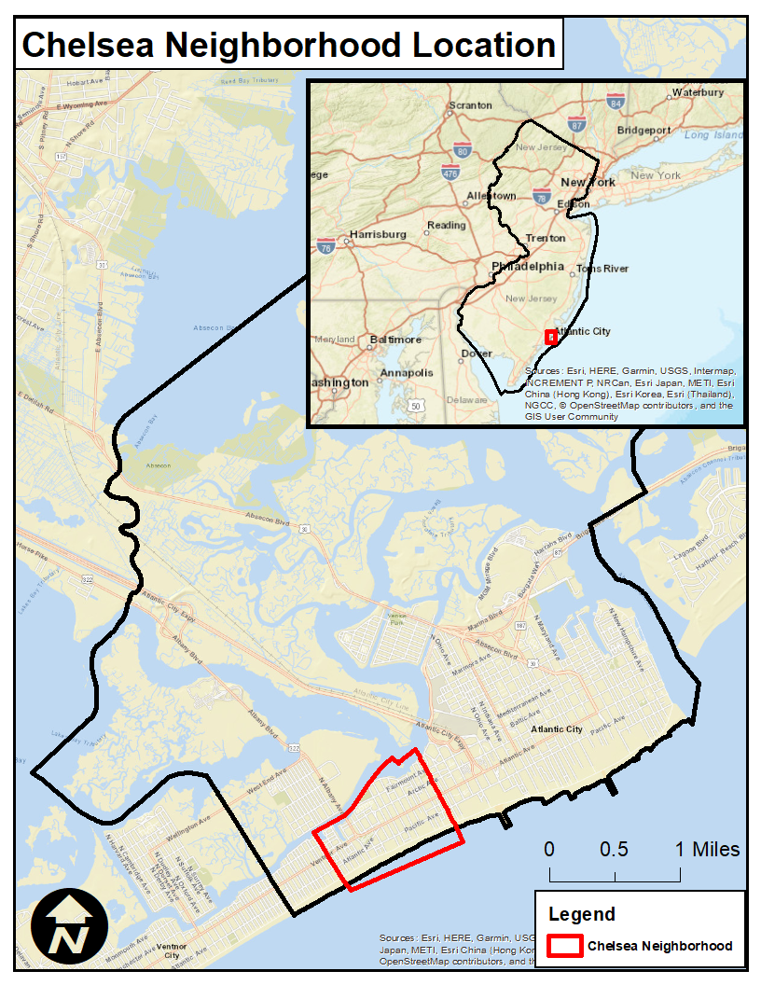
The Neighborhood is home to dozens of architecturally significant residential and commercial buildings dating to the early 20th Century. The development of the Tropicana and several additional high-rise residential structures in the second half of the 20th Century added density to the Neighborhood. More recently, the Gateway project has kicked off the next phase of the Chelsea Neighborhood’s evolution.
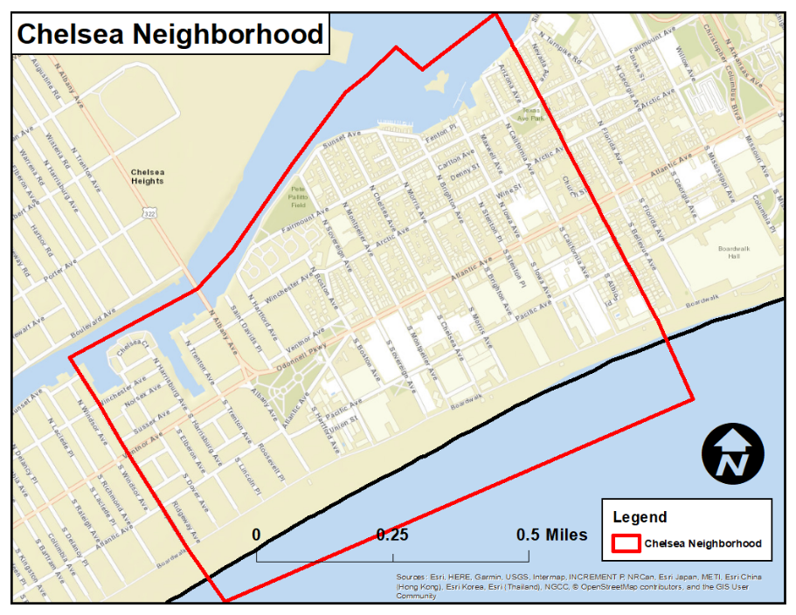
Due mainly to Atlantic City’s economy of tourism and gaming, and associated low wages, however, Chelsea residents, like residents in the rest of the City, have experienced limited economic opportunity in recent decades. The lack of economic diversity in the City has exacerbated longstanding and deep rooted challenges such as poverty and unemployment, blight, low educational levels, crime and other negative indicators.
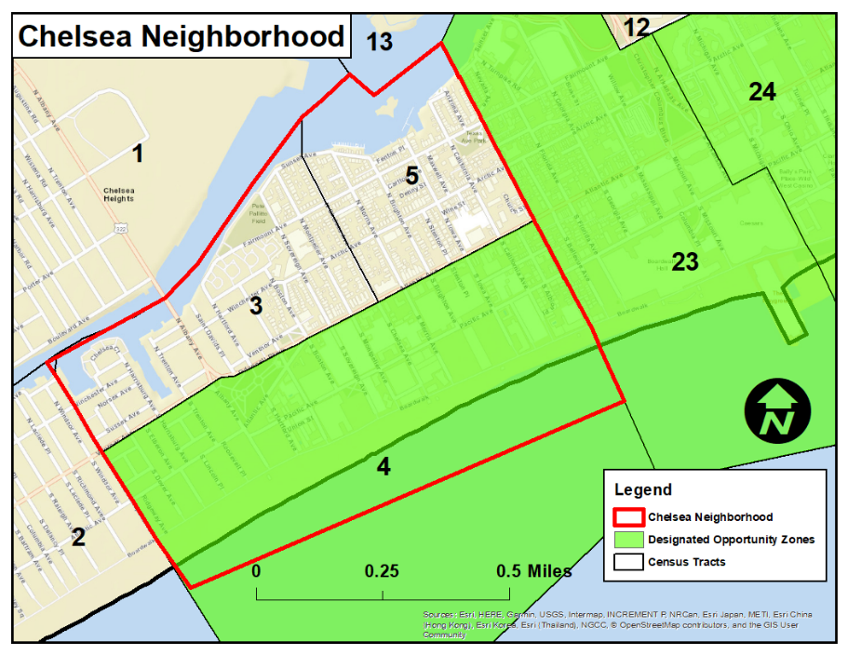
Although the $220 million Gateway Stockton/South Jersey Gas project has provided an opportunity for additional investment in the Chelsea Neighborhood, the majority of local small business owners and residents have not yet experienced positive economic impacts as a result. Since 2018, property taxes have increased, residents feel unsafe in the neighborhood, and a significant number of storefronts are still vacant. While the trend of housing costs increasing in the Neighborhood predates the development of the Gateway Stockton/South Jersey Gas project, gentrification and displacement could be unintended byproducts that begin to adversely affect residents and business owners in the years to come. This plan recognizes the threat posed by these new developments and includes strategies intended to strengthen homeownership, support existing businesses, and foster a vibrant community.
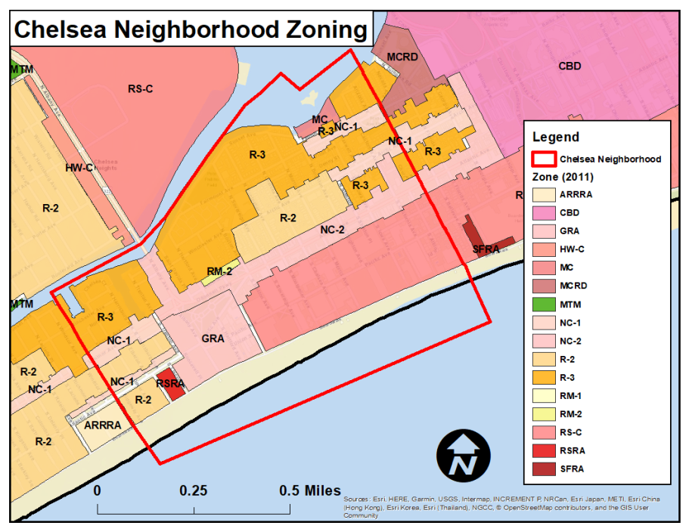
Despite the challenges there are significant opportunities. Directly adjacent to the Gateway development, for example, is a block with eight storefronts, four of which remain vacant. Overall, the Neighborhood has 27 vacant commercial storefronts. This plan envisions a focus on both recruiting more businesses, and helping existing businesses become stronger and upgrade into better space where appropriate. Similarly, the hundreds of vacant housing units provide an opportunity to provide safe, affordable housing while cleaning up blight and increasing safety. Partners in the creation of this plan look forward to building on the neighborhood's considerable strengths, and partnering to address its challenges, to make it a place all can be proud of.
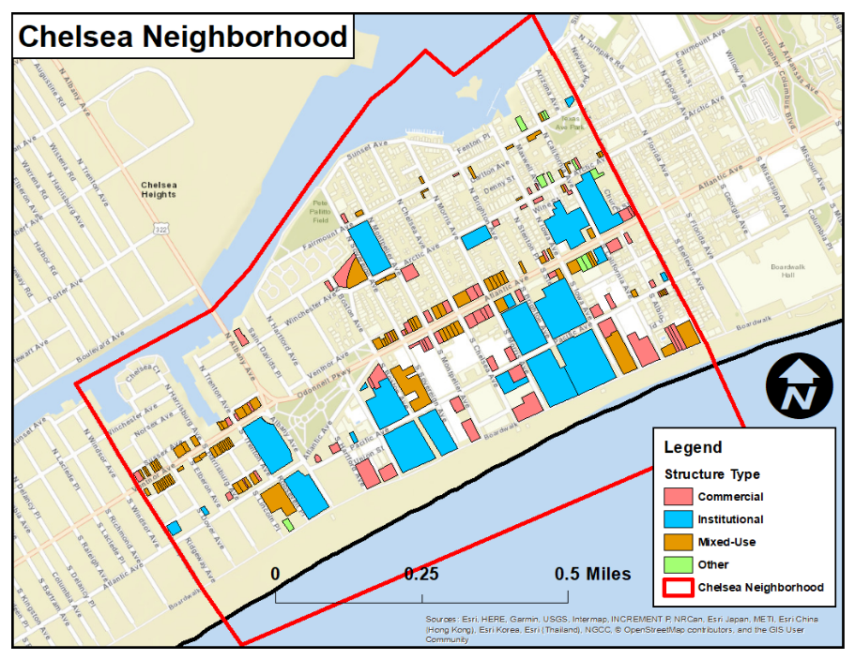
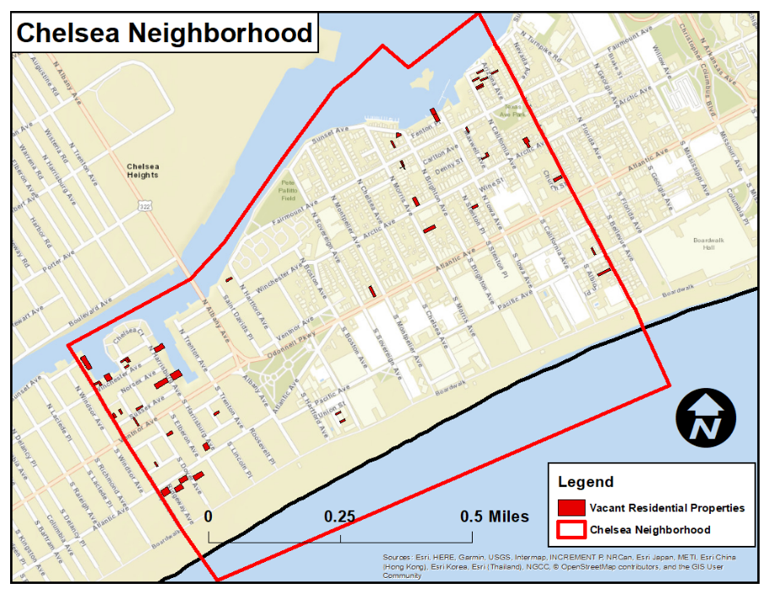

Conditions and Need for Revitalization

People
Chelsea is a large neighborhood in Atlantic City with a population of 10,433 residents. The neighborhood’s population decreased slightly from 10,482 residents in 2010. Overall, Chelsea is home to over 27% of Atlantic City’s total population.
Chelsea is a diverse community with a population that is 42% Hispanic and Latinx. 34% of the population identify as Asian, while 15% identify as non-Hispanic White. Residents identifying as African American, ‘Other’, and ‘Two or more races’ all comprise 4% of the population respectively. Additionally, approximately 45% of the population report having limited English proficiency.
The median age in the neighborhood ranges from 29.6 to 42.5 depending on the census tract. 26% of the population is under the age of 18, while people aged 60+ comprise 16% of the population. Approximately 10% of Chelsea households are headed by single mothers.

Income
The median household income for Chelsea ranges from $31,115 to $38,054 - it has been steadily increasing since 2000. The median household income for Atlantic City is $27,786. While this increase in household income has been a positive trend in the neighborhood, the poverty rate in Chelsea is high, at 33%. The poverty rate in Atlantic City overall is slightly higher, at nearly 38%.
Before the current pandemic, the unemployment rate for the neighborhood ranged from 6.3% to 12.6% depending on the census tract. The unemployment rate for Atlantic City was approximately 14% and the unemployment rate for the county was nearly 10%.

Education
The 2014-2018 American Community Survey estimates that none of the population between 16 and 19 have dropped out of high school. For adults aged 25 and higher, nearly 54% of residents have at least a high school diploma, and nearly 20% have a bachelor’s degree or higher. Citywide, 74% of adults aged 25 and above have at least a high school diploma and 16% have a bachelor’s degree or higher. Statewide, nearly 90% of people aged 25 or over have at least a high school degree and 39% have a bachelor’s degree or higher.
The percentage of households in Atlantic City with a computer is 74.3% compared to 90% statewide. The percentage of households in Atlantic City with access to broadband internet access is 62.5% compared to 84.1% statewide.

Housing
There are a total of 4,921 housing units in the Chelsea neighborhood. Approximately 31%, or 1,530 of those units, are vacant. Moreover, 800 of them are non-seasonally vacant, suggesting that while seasonal vacancy contributes in large part to the overall vacancy in the neighborhood, and over 16% of units are vacant year round.
Additionally, 48% of the housing units are renter occupied, while approximately 21% are owner occupied. The housing stock in Chelsea is older, with 67% of units built prior to 1960.
Housing costs compared to wages are high in the Chelsea Neighborhood. Approximately 53.25% of homeowners spend more than 30% of their income on housing and 27.32% spend more than 50% of their income on housing. Renters are also facing high housing cost burdens. In Chelsea, 67.7% of renters spend more than 30% of their income on housing and 41.26% of renters spend more than 50% of their income on housing. There are at least 60 low-income residential households that receive federal housing subsidies. The 2018 Point-In-Time Survey identified 437 homeless individuals in Atlantic City/Atlantic County.
The median home value in the Chelsea Neighborhood is $166,500 while the median rent is $994 per month. In 2017, there were 181 residential sales in Chelsea with the median sales price of $69,567.

Health
Average life expectancy from birth for a Chelsea resident is 77.2 years compared to 74.7 for the rest of Atlantic City and 80.2 for the State of New Jersey.
Approximately 71.7% of adults report having a personal doctor or health care provider compared to 74.6% citywide and 79.2% statewide. Approximately 25.01% of Chelsea residents are uninsured compared to 15.69% of residents citywide and 8.47% residents statewide.

Evidence of Neighborhood Distress
The Area Median Income (AMI) of the Atlantic City – Hammonton, NJ Metropolitan Statistical Area (MSA) is $76,900. Approximately 65.5% of households in the Chelsea neighborhood make less than 50% of AMI ($38,450), while 79.5% of households make less than 80% AMI ($61,500).

Photographs of Neighborhood Conditions

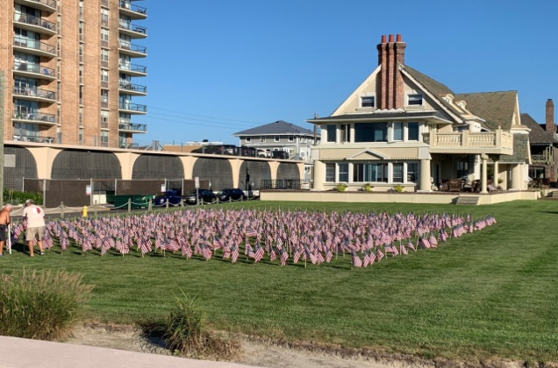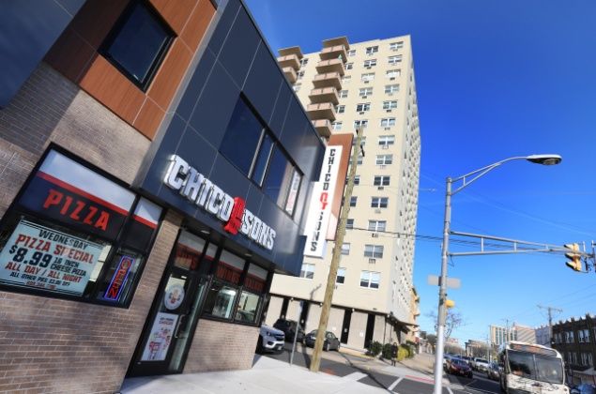
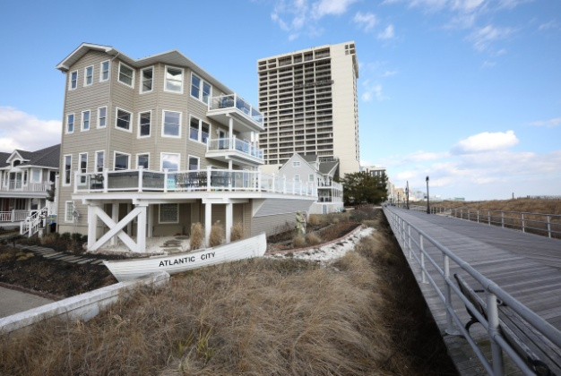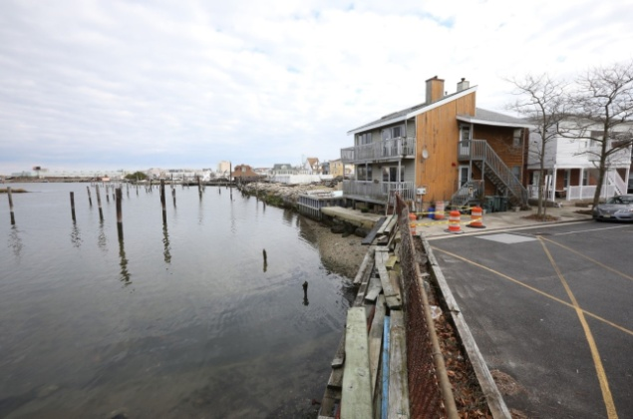
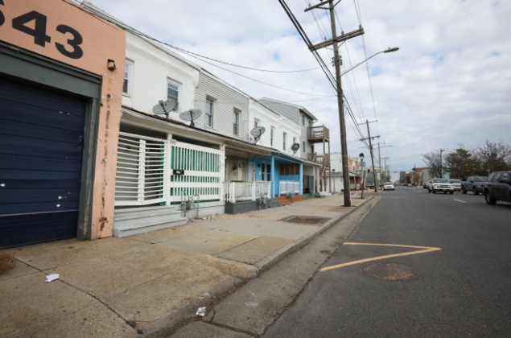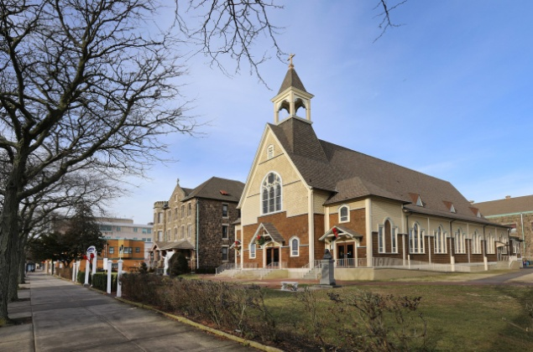

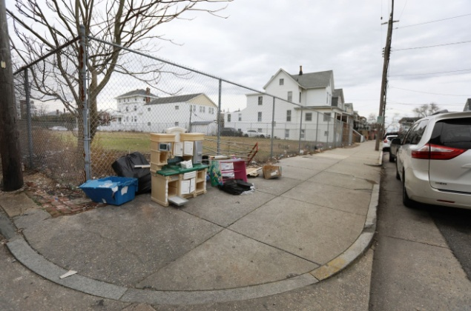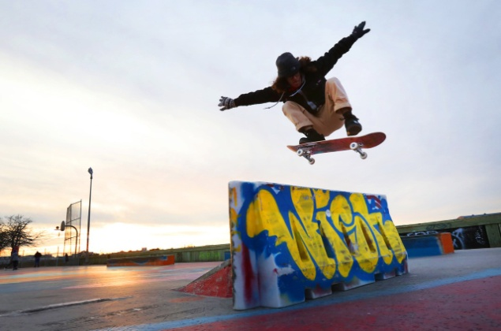

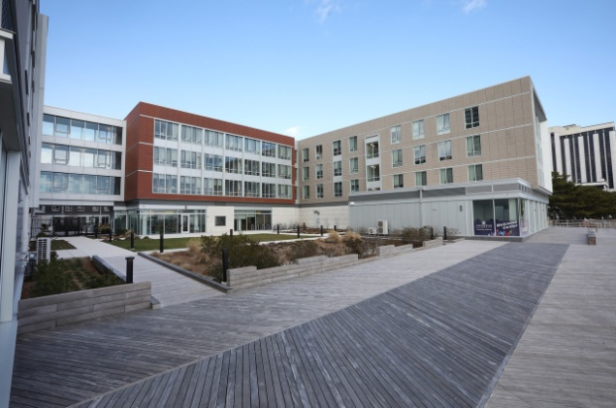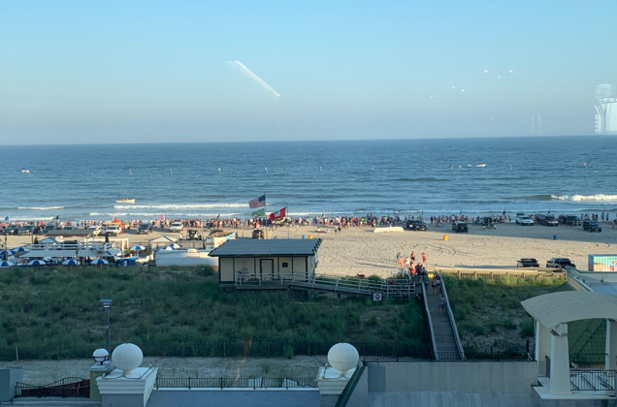

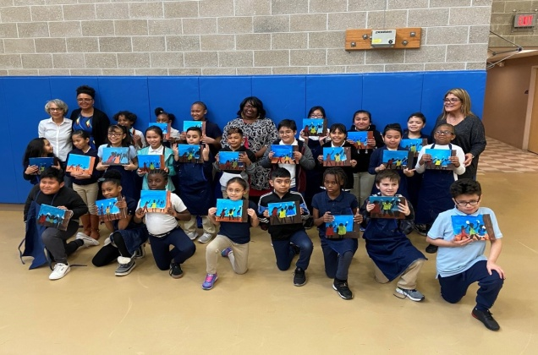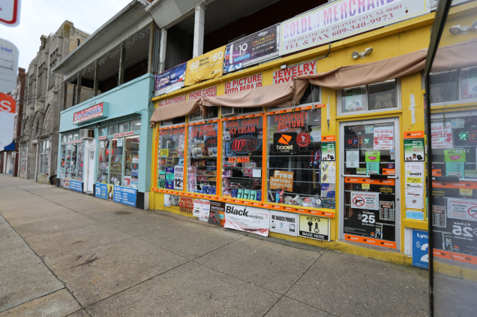

Description of Other Plans
The 1978 Atlantic City Master Plan set in motion the development of new structures in Chelsea that followed the legalization of gambling, many of them can still be found in the Neighborhood. The main goals and objectives of the plan were to: accelerate development of casino hotels; enhance convention industry; expand tourism; expand retail opportunities; provide incentives for spin off growth; and promote balance by adding new housing, retail and other commercial. Language in the plan stated: “The Plan has taken active measures to guard against …casino gambling remaining isolated, self-contained and self-serving. Rather, the Plan proposes specific recommendations which aim to make such isolation impossible and to set in motion a ….cyclical reaction which will stimulate all sectors of the economy and will reach all parts of the population. This has been the primary goal of the Plan.” Conversely, zoning variances were granted for the casino hotels that did in fact create self-contained, isolated buildings, leading to the lack of economic opportunity, and the blight that continues to exist today.
The 2008 Atlantic City Master Plan included a comprehensive inventory of the development since the construction of the casino hotels, along with recommendations for each of the City’s neighborhoods. The goals and objectives included: provide opportunities for the continued growth of the City’s resorts and casinos while diversifying its tourism economy and meet the needs of local residents; encourage the redevelopment/revitalization of existing neighborhoods and provide pedestrian and bicycle connections between them; promote and reinforce the City as a desirable residential location; and promote academic uses to attract new economic development opportunities.
Recommendations for the Chelsea neighborhood included: maintenance of neighborhood characteristics and revitalization; redevelopment of the former Masonic Temple; improvement of the Black Horse Pike Corridor as an entrance to Atlantic City; reduction of density as it currently exists and eliminate unnecessary conversions to multi-family dwelling units; coordination of a neighborhood committee or task force to work closely with the Code Enforcement Department.
The 2016 Master Plan Re-exam captured the decline of the casino industry, the significant decrease in property value, and the effects of Sandy. Goals, objectives and recommendations included: create attractive neighborhoods that are affordable, and well-served to provide a high quality of life for the residents; strengthen and improve City-wide and neighborhood commercial districts as centers of employment, shopping, services, entertainment and education; integrate the design and use of the Boardwalk as the prime destination corridor connecting various destinations including the all-important beach to the City; and upgrade substandard properties in the City through code enforcement efforts, education, ordinance amendments and other initiatives.
The Plan also encourages and promotes greater home ownership opportunities through increased access to mortgage financing (CDBG Funding) and production of for-sale housing; and the establishment of a reliable and trustworthy Community Development Corporations (CDC) to utilize 501(c)3 status to procure grants. Additional strategies are to: Explore creative and non-conventional methods such as Community Land Trust (CLT) to mitigate anticipated workforce housing shortages in the City; Encourage the use of mechanisms such as payment in lieu of taxes to assist with new construction and improvements; Encourage the second home ownership market in the city; Provide a vibrant and diverse economic environment which will protect and enhance the long term economic and social interests of present and future residents in order to maintain and improve the City's overall quality of life; Provide access and information on new small and low interest loans available to local businesses. This plan also encourages and promotes: Support for the arts and culture in the City by focusing on historic connections and leveraging the existing entertainment market to provide opportunities for local artists; Investigates the ideas of making Atlantic City a regional if not national example of resiliency design, education and planning; Recreational activities along the back bay and consider partnerships with private property owners to provide access for canoeing and viewing wildlife and waterborne transportation. Investigate opportunities for water sports to be provided access in the back bay and beach areas, to facilitate their development within the City; Improved and expanded cultural, non-athletic, and recreational opportunities for residents of all ages within the community; Historic preservation in order to maintain the City's unique character, protect existing historic resources and complement economic development efforts.
The 2015 Atlantic County Economic Development Plan identified the following “Leverageable Assets” - Airport and airspace opportunities; Federal Aviation Administration (FAA); Stockton University and Atlantic Cape Community College; ACDEVCO; Development, redevelopment, and repurposing opportunities; Casino Reinvestment Development Authority. Key industries to be targeted included: Aerospace and Aviation, Life Sciences, Tourism, Specialty Manufacturing, Entrepreneurial Business Services.
The 2012 Tourism District Master Plan included the following recommendations for Chelsea: construct the animated light feature attractions and institute multi-seasonal programming and events. The Design Principles for the Chelsea District encourage unique, eclectic, one-of-a-kind fashion stores and cafes that have an intimacy and scale that provide a unique experience for the visitor. The Chelsea District provides offerings unavailable to visitors anywhere else. In complement to the “main street” feel of the Atlantic Avenue District, the Chelsea District provides an even further level of locality. The Chelsea District is one which is influenced by both the Arts District to the East and Ventnor City to the West. The transitions between each district allow for a highly unique offering, and promote local influence and prosperity.
District Characteristics: Street furniture (including, but not limited to: seating, lighting, decorative landscaping, wayfinding elements and waste systems) to create pedestrian nodes along Atlantic Avenue within the Chelsea District; Unique pedestrian lighting elements can include tree lanterns and string lights highlighting specific nodes within the Chelsea District. Vertical banners should be placed on lighting elements to provide event promotion and program. Paving should be sophisticated yet artistic and hierarchic intersections should be denoted with specialty paved cross walks. State of the art bicycle racks should be located within the pedestrian nodes, and to promote an ease of circulation for cyclists. Local tenant / merchant signage / chalkboards should be located on the sidewalk to reinforce the boutique nature of the Chelsea District and public art should be placed appropriately to pedestrian spaces reflecting the work of local artisans.
Overall Improvements: The design of the façades should include awnings that have unique designs, colors, and accents. The storefronts along the street should be of an infill type with substantial architectural piers and corners and be well lit. It is encouraged that every tenant façade be different. The interior lighting should allow for the sidewalk pedestrian to see into the tenant space. Façade signage should be unique, self-illuminating and sophisticated. Stores should be encouraged to display their merchandise along the sidewalk adjacent to their stores but in a tasteful and artful manner.
The 2015 Gateway Redevelopment Plan promotes the following goals: strengthen and improve City-wide and neighborhood commercial districts as centers of employment, shopping, services, entertainment and education; promote academic and affiliated campus uses in the vicinity of already established centers at Stockton College and Atlantic Cape Community College (ACCC) to attract new economic development opportunities to the City; and encourage the development of a diversified economic base that generates employment growth, provides increased tax ratables, and increases income levels
The 2018 University District Overlay is intended to promote the growth of the university and other educationally related uses in the area within its boundaries and continue the reinvestment into the area from private and public development to provide for usage of land that is compatible with and conducive to the growth of such uses.

Municipal Support Letter
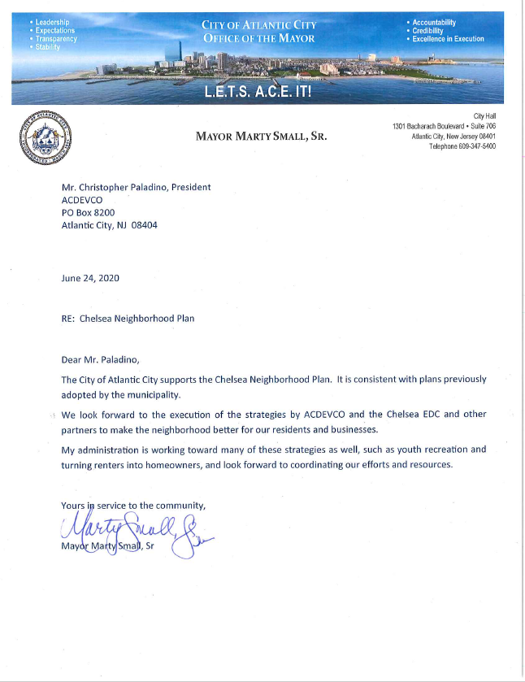

Section 6: Neighborhood Assets & Involvement

Neighborhood Assets

Community Assets
Medical:
AtlantiCare Occupational Health | 3830 Atlantic Avenue
AtlantiCare Behavioral Health | 13 N Hartford Avenue
AtlantiCare Urgent Care Atlantic City | 3830 Atlantic Avenue
AtlantiCare Physician Group, Primary Care Plus, Atlantic City | 3830 Atlantic Avenue
AtlantiCare Health Services Healthcare for the Homeless-Bacharach Blvd | 2009 Bacharach Boulevard
Reliance Medical Group (Family Planning/Ob-Gyn) | 4401 Ventnor Avenue

Transportation:
NJ Transit Bus #504 | Arctic Avenue & Fairmount Avenue
NJ Transit Bus #505 | Atlantic Avenue
NJ Transit Bus #507 | Atlantic Avenue & Albany Avenue
NJ Transit Bus #508 | Atlantic Avenue & Albany Avenue
NJ Transit Bus #509 | Atlantic Avenue & Albany Avenue
NJ Transit Bus #511 | Pacific Avenue
Atlantic City Jitney (Main Route) | Pacific Avenue & Ventnor Avenue

Educational:
Stockton University Atlantic City Campus | 3711 Atlantic Avenue
Our Lady Star of the Sea School | 15 N California Avenue
Sovereign Avenue School | 111 N Sovereign Avenue
Brighton Avenue School | 30 N Brighton Avenue

Parks/Recreation:
O’Donnell Memorial Park | Corner of S Albany Avenue and Atlantic Avenue
Pete Pallitto Field | Corner of N Sovereign Avenue and Fairmount Avenue
Sovereign Avenue Skatepark | Corner of N Sovereign Avenue and Sunset Avenue
Texas Avenue Playground | Corner of Texas Avenue and Fairmount Avenue
Arizona & Bay Memorial Park | Corner of Arizona Avenue and California Avenue

Community:
Boys & Girls Club (Chelsea Clubhouse) | 215 N. Sovereign Avenue
Salvation Army | 22 S Texas Avenue
WIC Office | 139 N Iowa Avenue
Spanish Community Center - Shore AHEC | 3900 Ventnor Avenue
Infant and Family Development | 2922 Atlantic Avenue

Celebrations/Events:
Asian New Year Festival | 111 N Sovereign Avenue
Multicultural Festival | 111 N Sovereign Avenue
Chalk About AC | Citywide
A.C Marathon | Citywide
Health Expo | 2 S Hartford Avenue
Atlantic City AirShow | Atlantic City Beach
Tết (Vietnamese New Year Celebration) | 15 N California Avenue

Fire and Police Stations:
Atlantic City Fire Department Station No. 4 | 2715 Atlantic Avenue
Atlantic City Fire Department Station No. 6 | 4025 Atlantic Avenue
Atlantic City Public Safety Building/  Police Department Headquarters | 2711 Atlantic Avenue

Retail/Commercial Corridor:
Atlantic Avenue | Between Harrisburg Avenue & Texas Avenue
Pacific Avenue | Between Albany Avenue & Texas Avenue
Albany Avenue | Between Bay & Atlantic Avenue
Ventnor Avenue | Between Annapolis Avenue & Albany Avenue
Boardwalk | Texas Avenue to Providence Avenue

Regional Assets
Beach, publicly accessible:
Atlantic City Beach | From Annapolis Avenue to Texas Avenue

Boardwalk:
Atlantic City Boardwalk | From Annapolis Avenue to Texas Avenue

College/university (4-year):
Stockton University Atlantic City Campus | 3711 Atlantic Avenue

Performance Space:
Tropicana Showroom at the Tropicana | Brighton Avenue and the Boardwalk
Phoenix Hall | 203-205 N. Sovereign Avenue

Medical:
AtlantiCare Occupational Health | 3830 Atlantic Avenue
AtlantiCare Behavioral Health | 13 N Hartford Avenue
AtlantiCare Urgent Care Atlantic City | 3830 Atlantic Avenue
AtlantiCare Health Services Healthcare for the Homeless-Bacharach Blvd | 2009 Bacharach Boulevard

Municipal Revitalization Priorities
The 2015 Gateway Redevelopment Plan was developed to usher in new development in the Chelsea Neighborhood. This Redevelopment Plan led directly to the construction of South Jersey Gas’ headquarters and Stockton University’s Atlantic City campus. Similarly, in 2018, the City developed a “University District” zoning overlay that will further support the build-out of Stockton University’s Atlantic City campus with complementary uses that will benefit students, employees of local businesses, and neighborhood residents.
Census Tract 4, which encompasses the area south and east of Atlantic Avenue between Annapolis Avenue and Texas Avenue, has been designated as an “Opportunity Zone”.
The City of Atlantic City, in partnership with the Casino Reinvestment Development Authority, authorized a Special Improvement District (SID) in 1992 that stretches into the Chelsea Neighborhood. The SID covers both sides of Atlantic Avenue from Texas Avenue to Trenton Avenue and extends to cover all properties south and east of Atlantic Avenue.
The Soldiers’ Memorial Monument at the confluence of Albany Avenue, O’Donnell Parkway, and Ventnor Avenue is on the National and New Jersey Registers of Historic Places. There are more than 100 additional structures in the Chelsea Neighborhood that are eligible for inclusion on one or both lists. The City of Atlantic City’s new local Historic Preservation Commission, chaired by a Chelsea Neighborhood resident, will be evaluating local designation of properties in the coming years.
The City of Atlantic City continues to make significant investments in public buildings and infrastructure in the Chelsea Neighborhood. The below projects are ongoing or planned to begin before the end of 2020:
- Milling & Paving Atlantic Avenue (from Texas Avenue to California Avenue)
- Milling & Paving Chelsea Area & Albany Avenue (from Beach to Bay)
- South Jersey Gas Connector Project (Atlantic Avenue & Albany Avenue)
- Upgrades to Fire Station #4 (Emergency Generator Installation & New Terracotta Roof)
- Upgrades to Fire Station #6 (Emergency Generator Installation)
- LED Street Light Conversion (Atlantic Avenue & Pacific Avenue)
- AC Resilience Project
  - Replacement of City-owned bulkhead along the Bay (Texas Avenue to Annapolis Avenue)
  - Traffic Light Upgrades
  - Flood proofing of City-Owned buildings (Public Safety Building, Fire Station #4)
  - Outfall Check Valve evaluation/replacement (Bayside check valves)

Recent Investment
Since 2015, the Chelsea Neighborhood has experienced a significant spike in private investment. More than 600 housing units have been developed in the City - many in close proximity to Stockton University’s Atlantic City campus project in the Chelsea Neighborhood. In 2022, more than 400 additional beds will be added to the campus marking another significant investment in the neighborhood.
There have been 9 permitted projects developed - these projects include South Jersey Gas Headquarters, Stockton University’s Atlantic City campus buildings, renovations at The Tropicana, as well as residential and commercial projects along Ventnor Avenue (Bayside).
Numerous commercial properties have changed hands over the past 5 years with several being completely renovated. Examples include: The Wonder Bar and Beat the Daily Grind Cafe.

Neighborhood Involvement
ACDEVCO and the Chelsea EDC led a robust community engagement process for the development of this neighborhood plan, despite the difficult conditions resulting from the global Covid19 pandemic. Working in partnership with groups such as the Boys & Girls Club, Sovereign Avenue School, Dynesty Alliance, Our Lady Star of the Sea, Stockton University, and the Hispanic Association of Atlantic County, ACDEVCO and the Chelsea EDC are poised to leverage these relationships to benefit the Chelsea Neighborhood.

Community Organization Effectiveness
ACDEVCO has been active in the Chelsea Neighborhood since 2015. During that time, ACDEVCO has led the development of several transformative projects that have dramatically improved the look, feel, and function of the Chelsea Neighborhood. These catalytic projects have spurred private investment and set the stage for a transformative neighborhood revitalization effort.
- South Jersey Gas Corporate Headquarters – 3800 Atlantic Avenue
- Stockton University Public Parking Garage – 3830 Atlantic Avenue
- Stockton University Atlantic City Campus – 3711 Atlantic Avenue
- Stockton Atlantic City Apartments - 3701 Boardwalk
- Stockton University Gateway Project (Phase 2) – 16 S. Providence Avenue

Community Support and Engagement
ACDEVCO and the Chelsea EDC have been actively engaging residents since their inception in 2015 and 2019, respectively. Over the past 12 months, ACDEVCO and the Chelsea EDC have targeted their engagement around neighborhood beautification and revitalization. These activities connected seamlessly to the Neighborhood Planning effort that took place during the first half of 2020. These activities included:
- Multicultural Festival at Sovereign Avenue School – June 6, 2019
- Chalk About AC – Arts Foundation O’Donnell Park event - June 22, 2019
- Atlantic City AirShow – August 21, 2019
- Veterans Heritage Tour w/ Stockton University – September 15, 2019
- Chelsea Restaurant Showcase for Stockton students – September 26, 2019
- A.C Marathon – October 20, 2019
- MLK Day of Service Community Clean Up organized by Stockton University - January 21, 2020
- Asian New Year Festival – January 28, 2020
- Tropicana Neighborhood Plan launch – January 28, 2020
- Our Lady Star of the Sea Plan meeting – February 10, 2020
- Tết (Vietnamese New Year Celebration) – February 14, 2020
- Jacob Lawrence Educational Activity - Sovereign Avenue School - February 18, 2020
- Jacob Lawrence Billboard unveiling - February 18, 2020
- ACDEVCO sponsored food donation program during Covid19 – April 20, April 22, May 8
- Housing & Beautification Focus Group (Zoom) – May 5, 2020
- Community - Youth & Recreation Focus Group (Zoom) – May 7, 2020
- Youth Focus Group (Zoom) – May 11, 2020
- Public Safety Focus Group (Zoom) – May 12, 2020
- Economic Development & Jobs Focus Group (Zoom) – May 14, 2020
- Our Lady Star of the Sea Focus Group on Youth & Community (Zoom) – May 19, 2020
- Graduation 2020 Billboard unveiling – June 14, 2020
- Food distribution by Hispanic Alliance of Atlantic County – April, May, June 2020
- Chelsea Neighborhood Association Community Meetings – every third Thursday of the month

Section 7: Proposed Vision, Strategies, Activities & Outcomes

Vision Statement
Building on Chelsea's strengths, this plan seeks to chart a path for a better future. We seek to foster community, increase economic opportunities, and provide for better housing for all Chelsea residents.

Strategies
The Chelsea Neighborhood Plan outlines strategies in 5 distinct yet interconnected focus areas meant to address the long-term revitalization of the community. The focus areas are: Strengthen Community, Safety & Resident Wellness, Youth & Recreation, Housing, and Economic Development.
Grounded in data and the engagement of Neighborhood residents and stakeholders, this plan seeks to build on the Chelsea Neighborhood’s assets, address perceived weaknesses and threats, and position the community to take advantage of opportunities for everyone to thrive. The strategies in this plan address the social determinants of health – economic stability, neighborhood and physical environment, education, food, community and social context, and the health care system. Broadly speaking, the plan’s 5 focus areas seek to foster community, increase economic opportunities, and provide for better housing for all Chelsea residents.

Focus Area #1: Strengthen Community
Chelsea has an incredible diversity of cultures. Engaging residents, promoting the arts, and fostering the leadership capacity of Chelsea residents are paramount for success.

Strategy 1.1: Celebrate the Chelsea Neighborhood’s Diversity
The diversity of the Chelsea Neighborhood was consistently identified as one of its strengths during the public input process. With 42% of the Neighborhood’s population identifying as Latinx or Hispanic, 34% identifying as Asian (including Bangladesh, Pakistani, Chinese, Vietnamese), and 4% identifying as African American, there is a wide variety of cultures present in Chelsea, each with its own rich history. At Sovereign Avenue School, 18 different languages are spoken and 21 countries are represented. Neighborhood residents want both an understanding of their own culture, and to celebrate other cultures. Building on established events and the work done by existing partners, ACDEVCO and Chelsea EDC are looking to help take these events to the next level.
In addition, there is strong interest in creating a Community Hub; a place to celebrate and preserve Chelsea’s diversity and to host community programming, educational offerings, and trainings.
Potential activities include:
- Cultural Events & Programs: Work with cultural organizations to organize, promote, and facilitate events and programs highlighting the diversity of the Chelsea Neighborhood; the fine, performing, and culinary arts are areas expected to be highlighted.
- Promote International Cuisine: In partnership with local grocers and restaurants, promote the diverse culinary offerings found in Chelsea, coordinate food-related programs, and market the Neighborhood as an “International Food District”.
- Building the Capacity of Cultural Organizations: Help organizations to execute elements of this plan. Examples would be training on nonprofit management, grant writing, and financial and program management.
- Community Hub: Assist in establishing a place for Neighborhood residents and businesses to utilize for education, referrals and resources. This Center will have space for events, activities, and informational sessions and will be supported by community partners such as Stockton University, AtlantiCare, and other neighborhood groups.

Strategy 1.2: Engage residents through the Arts
Arts programs and activities will foster individual and community creativity and expression by engaging residents of all ages and cultures. The Plan will work through the Atlantic City Arts Foundation (ACAF), the Atlantic City Arts Commission, Stockton’s Noyes Museum of Art, the African American Heritage Museum of South Jersey, and nonprofit partners such as MudGirls Studio, to engage youth and adults with cultural programs.
Potential activities include:
- Fine & Performing Arts Programs: Support established partners as they expand their fine and performing arts programs for Chelsea residents.
- Public Art Installations: Work with arts organizations on the development and installation of permanent public art by local artists.
- Arts & Beautification: Work with arts organizations to identify artists for neighborhood beautification projects (e.g. murals, vacant storefront window displays and graphics, branding and promotional art, decorative bike racks, decorative waste receptacles, decorative electrical boxes).

Strategy 1.3: Empower residents to become community leaders
The residents of the Chelsea Neighborhood have a deep love of their community and are interested in expanding their civic involvement. Resident leaders can play a role in the implementation of this plan. By offering regular informational and educational sessions on critical and timely topics such as immigration, anti-racist/implicit bias trainings, and health issues, Chelsea EDC and ACDEVCO hope to further promote a knowledgeable and confident resident base, from which leaders will evolve. The Chelsea Neighborhood Association has been active for more than 45 years and has served as a springboard for resident involvement with neighborhood and municipal affairs. It will look to expand its membership, help develop a network of block captains, and promote active resident participation in the implementation of this plan. It will also help residents engage with smaller organizations through volunteerism and sponsorships.
Over the next five to ten years, ACDEVCO will support resident leaders through these activities:
- Develop a network of Block Captains: Engage Chelsea Neighborhood residents in the creation of block associations and the election of block captains to assist with community building activities. Block captains would receive training on topics such as code enforcement, block beautification, and leadership.
- Promote Volunteerism & Active Community Participation: ACDEVCO and Chelsea EDC will work to engage residents through volunteer fairs and referrals to local organizations serving the Chelsea Neighborhood.
- Resident Leadership Training: ACDEVCO will work with Atlantic City groups looking to reinstate the Lead AC program and/or develop new leadership development programs or trainings for residents, including a proposed program for youth leadership development.

Strategy 1.4: Facilitate opportunities to connect the Chelsea community to anchor institutions and employers
The relationship between Chelsea residents and Neighborhood anchor institutions, students, employers and employees, is central to this plan’s success. Approximately 2,000 Stockton and South Jersey Gas affiliates use the Neighborhood daily. The goal is to have students and employees frequent Neighborhood restaurants and businesses. A combination of events, activities, and programs designed to foster communication and interaction among and between residents, Stockton and South Jersey Gas affiliates, and other workers will help to forge a strong relationship between these groups, and lead to a Neighborhood goal of faculty, students and workers also becoming Chelsea residents.
Potential activities include:
- Neighborhood-wide Events: Coordinate and market all neighborhood events (e.g. neighborhood clean-ups, arts programming, cultural festivals, block parties, etc.) with and to the broader community (Stockton University, South Jersey Gas employees, and residents).
- Neighborhood Tours: Coordinating with Stockton University, City walking tours currently offered by a local historian will be expanded to cover Chelsea history, culture, architecture, and food.

Focus Area #2: Safety & Resident Wellness
Residents and stakeholders continually brought up issues that relate to the overall wellness of the community. Working to improve neighborhood safety, pedestrian and cyclist infrastructure, and healthy lifestyles pays dividends long into the future.

Strategy 2.1: Interventions for a safe community
Residents generally feel safe in the neighborhood; however, there are several areas of concern that residents want to see addressed. Addressing blighted property conditions and the need for social services will improve residents’ and visitors’ perceptions of the Chelsea Neighborhood. Building on the successful Neighborhood Coordination Officer (NCO) program implemented by the Atlantic City Police Department, a Crime Prevention through Environmental Design (CPTED) framework will engage residents, the ACPD, and other stakeholders while building trust in the community. Improvements to technology and the engagement of Stockton University – their Public Safety office and Criminal Justice Department – will result in Stockton students becoming Class 2 Officers in the community.
The activities below represent an example of ways ACDEVCO and Chelsea EDC will implement this strategy:
- Reporting Platform: Work with the City to establish an app that allows residents to report code enforcement issues. Work with residents to advocate for targeted code enforcement to ensure vacant, abandoned, and other nuisance properties are maintained and remediated to City standards.

- Partner with Social Service Agencies to Provide Outreach: Identify and refer individuals for health, housing, and social services focused on long term solutions.
- CPTED Training & Implementation: Work through the Chelsea Neighborhood Association to host CPTED training workshops for property owners. Provide small grants to participants to implement CPTED tactics.
- Lighting & Cameras: Coordinate with the ACPD to incentivize property owners and the City to install lighting in dark areas of Chelsea and ensure camera feeds are connected to the City’s network - areas of particular focus include Pacific Avenue and the “H Alleys”.

Strategy 2.2: Improve pedestrian and cyclist infrastructure
Chelsea is a largely walkable neighborhood, a fact much appreciated by residents. 23.7% of housing units in Chelsea do not have a car, and 22.2% of residents walk to work. However, there are safety issues involving speeding cars, dangerous crossings, and lack of bicycle and pedestrian infrastructure. Over the next 5-10 years, ACDEVCO and Chelsea EDC plans to build on the walkability of the Neighborhood to ensure the comfort and safety of pedestrians and cyclists. Building on this Neighborhood strength is important and steps will be taken to ensure Chelsea remains walkable into the future.
Potential activities include:
- Improved Pedestrian Infrastructure: Work with the City and other partners to develop, install, and maintain innovative pedestrian infrastructure improvements in Chelsea (e.g. decorative crosswalks, street trees, pedestrian countdown clocks, etc.).
- Decorative Bicycle Racks: Work with the Atlantic City Arts Foundation to commission decorative bicycle racks to be developed by local artists.
- Pilot Permanent Bicycle Infrastructure: In partnership with the City, pilot and evaluate several bicycle infrastructure improvements along key Neighborhood corridors with the goal of installing a permanent bicycle infrastructure in Chelsea by 2030.

Strategy 2.3: Promote an active and healthy lifestyle
This plan seeks to learn more about residents’ health concerns through the neighborhood urgent care, medical offices, and clinics with the goal of supporting residents as they address chronic health issues and lead healthy, productive lives. This strategy also promotes an active, healthy lifestyle for all residents through physical activity and accessible health care.
Potential activities include:
- Healthy Chelsea: Partner with local healthcare providers and institutions such as AtlantiCare and Reliance to ensure quality medical care. Partners will share information on health insurance and healthy living, including nutrition.
- Fitness Activities for All Ages: Work with partners to develop and facilitate fitness programming for all Chelsea residents. Activities may be geared toward different population segments, including seniors, adults, and youth.

Focus Area #3: Youth & Recreation
Improvements are needed to existing parks and recreational facilities as well as programming for Neighborhood youth. The Chelsea Neighborhood will benefit from the renovation of O’Donnell Park and the establishment of quality recreational programming for youth.

Strategy 3.1: Renovate & improve O’Donnell Park to make it accessible and actively used
The largest, most prominent green space in the Chelsea Neighborhood is O’Donnell Park. The park contains numerous memorials honoring those who served in conflicts from the Civil War through Vietnam. In addition, O’Donnell Park has distinctive landscaping and is equipped with electricity to be able to host outdoor events. During focus groups, residents called for the renovation of O’Donnell Park that maintains the memorials while allowing for Neighborhood events and activities to take place on a more wide-open expanse of green-space. There are three additional blocks of green space along O’Donnell Parkway that are also usable. This green space is more easily accessible to pedestrians and should also be improved.
Potential activities include:
- Redesign & Renovation of O’Donnell Park: Work with the City and the CRDA to hire a landscape architect to engage the community in planning for the future of O’Donnell Park. The resulting plan will guide the renovation of the park while maintaining existing memorials, improving landscaping, and ensuring accessibility of the park for active and passive recreation.
- Park Programs: Partner with neighborhood groups to host small- and medium-scale events (e.g. food truck festival, movie nights, yoga, farmers’ market, etc.) at O’Donnell Park.
- Friends of O’Donnell Park: Formation of a “Friends of O’Donnell Park” entity that can fundraise for and support the upkeep of O’Donnell Park. This group will advocate for municipal support for the park and apply for funding to support programming.

Strategy 3.2: Improve and expand recreational facilities in Chelsea
The quality and quantity of recreational facilities and programs, especially for youth, conveys a community’s priorities. The Chelsea Neighborhood contains several open space and recreational facilities; however, there was overwhelming public opinion that the physical appearance, safety, and programming of these spaces can be improved to better serve residents. This strategy will bring people together and help foster community.
Potential activities include:
- Improve and Expand Existing Facilities: Work in partnership with the City to secure resources to improve the maintenance of and expand the existing recreational facilities at Pallitto Field and the Texas Avenue Playground, as well as supporting neighborhood institutions to add or expand recreational facilities for the community.
- Organized Recreational Programming: Work with the City and local organizations to develop and promote a calendar of recreational programs offered by public and private organizations locally. Work to ensure programming is varied, accessible, and convenient.

Strategy 3.3: Partner with local and national organizations to increase access to youth programming
During a youth focus group, gaps in programming – especially life-skills and career-focused – were evident. Neighborhood youth want the opportunity to work in meaningful careers without having to move out of the area. Several local organizations (e.g. ACIT and the Boys & Girls Club) recognize these gaps and have begun expanding their life skills, educational, and career programming to expose area youth to career pathways in fields such as STEAM, Healthcare, IT, Green Energy, Building Trades, Culinary, and Aviation.
In addition to career-focused programming, organized recreational programming was found to be lacking. Cultural activities administered by organizations such as Dynesty Alliance, Atlantic County Hispanic Association, and faith based organizations, expose youth to cultural programming while teaching them other life skills. Additional programs (e.g. Junior Lifeguards, Soccer) can be promoted in the neighborhood as options before/after school or during the summer months.
Potential activities include:
- Youth Development: ACDEVCO and Chelsea EDC will work with local partners to promote their existing offerings as well as youth development courses on subjects of particular interest to Chelsea youth (e.g. balancing a check-book, applying for college and financial aid, etc). These organizations will also host career development nights focused on different pathways and industries.
- Youth Sports: ACDEVCO and Chelsea EDC will work with groups such as Youth in Motion, Asian American Sports Club of Atlantic City, and Atlantic City FC Soccer Team to develop youth sports teams (e.g. soccer, cricket, crew, etc.) that offer quality, affordable programming for boys and girls.
- Maker-Space, Robotics, and STEAM Programs: ACDEVCO, in partnership with Stockton University, the Boys & Girls Club, and Neighborhood Schools, will provide programming involving Robotics and other STEAM subjects. Mentors and volunteers will be sought from neighborhood employers such as South Jersey Gas. A Maker-Space will be developed in Chelsea to support youth entrepreneurs and creatives.

Focus Area #4: Housing
Housing needs were very clear – better quality housing priced within residents’ means. Supporting a diverse cross-section of individuals looking to purchase a home, improving the quality of the existing housing stock, and promoting the overall resilience and beautification of Neighborhood properties.

Strategy 4.1: Support individuals and families looking to own a home
Only 21% of housing units in the Chelsea Neighborhood are owner occupied. A plurality of residents rent their home (48%), while 16% of housing units are seasonally occupied and 15% are vacant. This plan seeks to facilitate and encourage Chelsea renters to become home owners, reducing the likelihood of long-term displacement and preserving the Neighborhood’s diversity, by hosting homeownership events and connecting them to housing and credit counseling organizations. ACDEVCO will also take a targeted approach to incentivize local homeownership for community builders such as teachers, mentors, social workers, first responders, and health care professionals, as well as employees of Tropicana, Stockton University, South Jersey Gas and other employers.
Potential activities include
- Homeownership Events: Work with local institutions and other partners to host events aimed at preparing people for the home buying process, through informing residents of the many down payment assistance programs offered, housing and credit counseling, and identifying or providing other incentives.
- Targeted Incentives: Work with CRDA and local institutions to create and administer targeted incentives (e.g. down-payment assistance, closing cost assistance, rehab costs, match-savings accounts) to targeted populations (e.g. first responders, government employees, teachers, employees of local businesses).

Strategy 4.2: Improve housing quality
For many housing projects, the cost to acquire and rehabilitate housing, or to buy land and build new construction exceeds the end market value. Additional costs are incurred to become FEMA compliant for flood protection. Using subsidies is an important strategy to ensure quality housing is available at affordable prices for those looking to purchase a home.
Leveraging ACDEVCO’s strength as a developer, they will work with local development partners and contractors to create a mix of quality and affordable residential and mixed-use properties that provide a lower-cost entry into the Neighborhood’s housing market. Vacant lots and structures will be developed in a manner that complements existing housing while offering new and different models of housing. ACDEVCO will also work with the City and their Abandoned Property Ordinance to acquire blighted properties for rehabilitation.
Potential activities include:
- Revitalize abandoned and vacant properties: Utilize local ordinances to acquire and rehabilitate properties that meet statutory definitions under the Abandoned Properties Rehabilitation Act.
- Acquire properties for new housing: Identify bank owned and distressed properties for sale to create new housing.

Strategy 4.3: Promote the preservation, resilience, and beautification of the Neighborhood’s homes
Properties in the Chelsea Neighborhood are among the oldest in Atlantic City. Over 67% of the Neighborhood’s homes were built before 1960 and more than 40% of all homes were built prior to 1940. Investment in the physical condition of the Neighborhood’s housing stock will make Chelsea more attractive to potential homebuyers. ACDEVCO and Chelsea EDC will work directly with property owners on this strategy. Improvements will happen incrementally; however, the plan anticipates private investments will contribute to these efforts once a few key properties have been rehabilitated. Historically significant homes and buildings will be prioritized for renovations rather than demolitions, where feasible.
- Home Repair & Resiliency Programs: ACDEVCO and Chelsea EDC will direct residents to existing home repair programs and partner with organizations such as ACIT to bring home repair classes to homeowners in the Neighborhood. ACDEVCO will partner with local organizations to implement weatherization, alternative energy, flood prevention, and other measures for homeowner occupants in the form of grants, technical support, and referrals.
- Property & Block Beautification: ACDEVCO and Chelsea EDC will hold monthly and annual competitions for residents to compete for community building and beautification projects (e.g. block parties, installation of decorative flags, landscaping improvements, banners, etc.)
- Housing & Neighborhood Advocacy: ACDEVCO will work with residents to advocate for sensible ordinances and policies related to housing maintenance, short-term rentals, and quality of life issues. ACDEVCO will also support residents’ efforts to have a portion of the Neighborhood designated as a Historic District and will ensure Chelsea benefits from planned infrastructure improvements.

Focus Area #5: Economic Development
The strategies in this section fall into two categories – supporting the businesses in the neighborhood; and providing resources to the residents to earn a living wage with opportunity for advancement. Diversifying the Neighborhood economy, supporting existing businesses, and preparing workers for good, local jobs will lead to a vibrant Chelsea.

Strategy 5.1: Promote and support businesses located in Chelsea
The Chelsea Neighborhood boasts a diverse mix of nearly 200 businesses, including restaurants, shops, and entertainment venues that cater to locals and visitors. Promoting and supporting these businesses is a major priority. The needs and interests of the businesses are different, but all would like to increase foot traffic in the Neighborhood and provide an appealing atmosphere for their customers. Moreover, there is an opportunity to promote and leverage the neighborhood’s designation as an Opportunity Zone. As the Chelsea Neighborhood becomes a fully-realized ‘University District’, businesses will need to adapt their marketing, appearance, and/or products. Collaborating with local and regional partners, ACDEVCO will ensure the businesses in Chelsea continue to serve Neighborhood residents, tourists, and Stockton students.
Potential activities include:
- Provide support to businesses: Partner with various agencies such as the Greater Atlantic City Chamber, the Latin American Economic Development Agency, New Jersey Community Capital, Stockton’s Small Business Development Center, the Small Business Administration, and others to administer training and support to small businesses, entrepreneurs, and micro-enterprises.
- Neighborhood Branding & Marketing: Engage in a branding process leading to the creation of a cohesive identity for the entire Chelsea Neighborhood. Specific marketing support will be given to the business district and to promote the Chelsea Neighborhood as a great place to live.
- Façade Improvements: Work with store owners to facilitate the cleaning up of nuisance signage, creation of appealing window displays, and the hiring of local artists to paint murals. ACDEVCO will encourage and support attractive, creative signage and facades.
- Filling Vacant Storefronts: Market vacant boardwalk and commercial district storefronts to businesses. Work with property owners to address barriers to leasing/selling space to a mix of different business types.

Strategy 5.2: Connect residents with Education and Career Pathways
Empowering youth (14-18), young adults (19-25), and workers (25+) through training, continuing education, and other career pathways is a long-term investment in the sustainability and resilience of the local economy. Currently, there are myriad skill and job training and entrepreneurial programs offered locally. The Atlantic County Vocational School District (ACVSD), the Atlantic County Workforce Investment Board (WIB), Atlantic Cape Community College (ACCC), Stockton University’s Small Business Development Center, and other local organizations all offer programs for adults to learn skills, certifications, and other continuing education programs. In addition, employers such as AtlantiCare, South Jersey Gas, and the FAA, actively recruit, train and provide pathways for career and financial growth.
Looking to the future, a coordinated approach to the structure and schedule of these offerings would benefit the youth, young adults, and residents of the Chelsea Neighborhood. Potential activities include:
- Resident & Employee Skill Training: Partner with local providers to directly support the participation of Chelsea residents and employees to secure additional training, certifications, and education. Support residents with degrees and training from other countries to translate their education to secure a comparable job.
- Bridging the Digital Divide: Working with internet providers and local institutions to increase the accessibility of the internet, access to computers, digital literacy education, and online learning.
- Youth and Young Adult Education & Training: Support the expansion of youth and young adult career exploration and training programs administered by local partners such as the Boys & Girls Club. Provide support and referrals for individuals seeking to complete their GED.
- Youth Employment: Work with local employers to facilitate summer and afterschool employment opportunities for Chelsea Neighborhood youth.

NRTC Investment as a Catalyst
The Chelsea Neighborhood Plan seeks to build on the area’s considerable assets, the strength of ACDEVCO and its partners, as well as the enthusiasm and commitment of Neighborhood residents. Throughout this plan document, the case has been made that the Chelsea Neighborhood is at a crucial tipping point. The recent investment by Stockton University and South Jersey Gas is significant; however, more work needs to be done to ensure that these projects produce equitable impact throughout the community for businesses and residents alike.
This plan lays out a series of strategies focused on: Strengthening Community, Safety & Wellness, Youth & Recreation, Housing, and Economic Development. The strategies serve to channel investment into projects, programs, and activities that positively impact Chelsea and build on the work that Chelsea EDC has done engaging youth, seniors, and the business community. Over the course of this plan’s 10-year horizon, ACDEVCO will undoubtedly work with other partners to leverage their resources and strengths while implementing this plan.
ACDEVCO has the experience and track record needed to affect real, positive change in the Chelsea Neighborhood. From serving as the developer for both the Stockton University and South Jersey Gas projects to their continued support for local organizations such as Chelsea EDC, ACDEVCO remains committed to the long-term revitalization of the Chelsea Neighborhood. Utilizing the NRTC program, the work that still needs to be done to fully realize the Chelsea Neighborhood’s vision for the future will happen sooner and in a more coordinated fashion. The opportunity to build-out a shared vision for Chelsea in 2030 was an important exercise to ensure that ACDEVCO, local stakeholders, and residents know how to work collectively and collaboratively to achieve this plan’s aims.

Projected Strategies, Activities, and Outcomes – Form NP-3
Strategies | Activities | Projected Outcomes | Evaluation | Data Source
Strategy 1.1: Celebrate the Chelsea Neighborhood’s diversity | Cultural Events & Programs | 5-10 events/programs annually celebrating Chelsea’s cultural diversity | Increase in the number of residents who participate in neighborhood events | Resident Survey; Chelsea calendar of events; number of people that attend events
 | Promoting International Cuisine | Hold 2-3 food-related events/programs annually; Develop marketing/branding for the “International Food” district | Increase in the number of residents who participate in neighborhood events; Completed branding initiative | Resident Survey; Chelsea calendar of events; increased sales at international restaurants; Before/After photos
 | Building the Capacity of Cultural Organizations | Expand programming offered; expand programming; increase funding | Increased membership in organizations; | Data from organizations
 | Community Hub | Establishment of a Community Hub space in Chelsea
Strategy 1.2: Engage residents through the Arts | Fine & Performing Arts Programs | 5 arts events/programs annually in Chelsea | Increase in the number of residents who participate in neighborhood events | Resident Survey; Chelsea calendar of events
 | Public Art Installations | Install at least 1 new public art installation annually
 | Arts & Beautification | 3 projects annually
Strategy 1.3: Empower residents to become community leaders | Develop a network of Block Captains | Have a designated block captain on each block in Chelsea
 | Promote Volunteerism & Active Community Participation | Hold an annual volunteer fair in the Chelsea neighborhood | Increase in the number of residents who participate in neighborhood events | Resident Survey; Chelsea calendar of events
 | Resident Leadership Training | Graduate 20 neighborhood residents from formal leadership trainings
Strategy 1.4: Facilitate opportunities to connect Stockton students and local workers with the Chelsea Neighborhood | Neighborhood-wide Events | Coordinate 30 distinct events/programs in the Chelsea neighborhood annually | Increase in the number of residents who participate in neighborhood events | Resident Survey; Chelsea calendar of events
 | Neighborhood Tours | Offer 10 tours of the Chelsea neighborhood annually | Increase in the number of people who participate in neighborhood events | Resident Survey; Chelsea calendar of events
Strategy 2.1: Interventions for a safe community | Reporting Platform | Facilitate the widespread use of a community-focused code enforcement reporting application
 | Partner with Social Service Agencies to Provide Outreach | Referral of those with needs into housing and programs | Decrease in homelessness, panhandling, addictive behavior | Social service data
 | CPTED Training & Implementation | Install CPTED treatments at least 40 residential properties | Decrease incidents of crime in Chelsea | ACPD data
 | Lighting & Cameras | Install lighting and cameras on all spots identified by Chelsea stakeholders | Decrease incidents of crime in Chelsea; Reduce percentage of residents who feel unsafe | ACPD; Resident Survey
Strategy 2.2: Improve pedestrian and cyclist infrastructure | Improved Pedestrian Infrastructure | Successfully advocate for the installation of countdown clocks at key neighborhood intersections; Successfully install decorative crosswalks in at least 2 neighborhood intersections | Increase percentage of residents who feel safe walking in the neighborhood | Resident survey
 | Decorative Bicycle Racks | Install decorative bicycle racks at key neighborhood institutions | Increase the percentage of residents who commute to work by bicycle | ACS data
 | Pilot Permanent Bicycle Infrastructure | Install permanent bicycle infrastructure in the Chelsea neighborhood | Increase the percentage of residents who commute to work by bicycle | ACS data
Strategy 2.3: Promote an active and healthy lifestyle | Healthy Chelsea | Provide support and referrals to residents to sign-up for healthcare | Reduce the percentage of Chelsea residents who are uninsured by 50% | ACS Data
 | Fitness Activities for All Ages | Coordinate 25 distinct wellness events/programs in the Chelsea neighborhood annually | Increase in the number of residents who participate in neighborhood events | Resident Survey; Chelsea calendar of events
Strategy 3.1: Renovate & improve O’Donnell Park to make it accessible and actively used by the neighborhood | Redesign & Renovation of O’Donnell Park | Engage at least 100 neighborhood residents in design charrettes for an O’Donnell Park renovation; Complete renovation of O’Donnell Park
 | Park Programs | Coordinate 24 distinct events/programs in the Chelsea neighborhood annually | Increase in the number of residents who participate in neighborhood events | Resident Survey; Chelsea calendar of events
 | Friends of O’Donnell Park | Creation of a dedicated “Friends of O’Donnell Park” entity
Strategy 3.2: Improve and expand recreational facilities in Chelsea | Improve and Expand Existing Facilities | Secure funding and support for the renovation, upkeep, and expansion of existing neighborhood recreation facilities
 | Organized Recreational Programming | Coordinate 24 distinct events/programs in the Chelsea neighborhood annually | Increase in the number of residents who participate in neighborhood events | Resident Survey; Chelsea calendar of events
Strategy 3.3: Partner with local and national organizations to increase access to youth programming | Youth Development
 | Youth Sports | Enroll at least 30 Chelsea youth in organized sports programs annually by 2030 | Increase in the number of residents who participate in neighborhood events | Resident Survey; Chelsea calendar of events
 | Maker-Space, Robotics, and STEAM Programs | Support the participation of at least 50 Chelsea youth in robotics and/or STEAM programs | Increase in the number of residents who participate in neighborhood events | Resident Survey; Chelsea calendar of events
Strategy 4.1: Support individuals and families looking to own a home | Homeownership Events | 25 community members will be able to purchase homes in the neighborhood | Increased rate of homeownership | ACS Data
 | Targeted Incentive | Support 5 first responders, government employees, teachers, or employees of local businesses purchase a home in Chelsea | Increase rate of homeownership | ACS Data
Strategy 4.2: Improve housing quality | Revitalize abandoned and vacant properties | All abandoned properties are rehabilitated into housing and commercial spaces | Decrease percentage of vacant or abandoned properties in Chelsea | ACS Data; USPS Data
 | Acquire properties for new housing | Acquire at least 10 residential properties; Develop at least 15 units of new housing in Chelsea | Reduce the number of bank owned properties; Increase the number of housing units in Chelsea | MOD-4 Data; ACS Data
Strategy 4.3: Promote the maintenance, resilience, and beautification of the Neighborhood’s homes | Home Repair & Resiliency Programs | Provide home repair grants to at least 25 owner-occupied residential properties | Reduction in number of properties in ‘poor’ condition | Parcel Survey
 | Property & Block Beautification | Award monthly and annual property and block beautification awards | Increase percentage of residents who view the neighborhood positively | Resident Survey
 | Housing & Neighborhood Advocacy | Designation of Historic District in Chelsea
Strategy 5.1: Promote and support businesses located in Chelsea | Provide support to businesses | Provide technical assistance to at least 15 neighborhood businesses  Provide grants to at least 20 neighborhood businesses
 | Neighborhood Branding & Marketing | Complete and implement a neighborhood-wide branding effort
 | Façade Improvements | Provide façade improvement grants to at least 10 neighborhood businesses
 | Filling Vacant Storefronts | Increase vibrancy, aesthetics, economic opportunity and amenities | Reduce the number of vacant storefronts in the neighborhood | Parcel survey; City records
Strategy 5.2: Connect residents with Education and Career Pathways | Resident & Employee Skill Training | At least 35 neighborhood residents will complete certifications with local education/training partners | Increase in Household Income | ACS
 | Bridging the Digital Divide | Net increase in the number of households with a computer; Net increase in the number of households with access to broadband internet access | Increase the percentage of households with a computer; Increase the percentage of households with access to broadband internet access | ACS
 | Youth and Young Adult Education & Training | At least 40 neighborhood youth and young adults will participate in job training/career pathways programming annually | Increase in the percentage of individuals under the age of 30 who are employed | ACS
 | Youth Employment | Support the employment of at least 20 neighborhood youth annually | Increase in the percentage of individuals under the age of 30 who are employed | ACS

Project Activities Budget & Timetable – Form NP-4
Proposed Activity | Estimated Cost | Sources of Funding | Uses of Funding | Role of Lead Organization and Partners | Timetable  Short  (1-2 years)  Medium  (3-5 years)  Long  (5+ years)
Cultural Events & Programs | $100,000.00 | ACDEVCO, AC Arts Foundation, CRDA, NRTC, Philanthropy | Event & Program Costs | ACDEVCO & Chelsea EDC will coordinate programming around a shared calendar; Dynesty Alliance, Our Lady Star of the Sea School; The Hispanic Association of Atlantic County, and the AC Arts Foundation will lead event/program development and implementation | Short Term  (1-2 Years)
Promoting International Cuisine | $50,000.00 | ACDEVCO, Atlantic City Chamber of Commerce | Marketing Costs; Program & Event Costs | ACDEVCO & Chelsea EDC will lead efforts to market the international dining scene in Chelsea and promote events and programs highlighting the culinary diversity in the neighborhood | Short Term  (1-2 Years)
Building the Capacity of Cultural Organizations | $75,000.00 | ACDEVCO, City of Atlantic City, Atlantic City Community Foundation, Community Foundation of South Jersey | Capacity building grants; training courses and conference attendance for cultural organizations | ACDEVCO and Chelsea EDC will work with neighborhood cultural organizations to become formal entities and have the capacity to manage programs/events | Medium Term  (3-5 Years)
Community Hub | $1,000,000.00 | ACDEVCO, Stockton University, City of Atlantic City, NRTC, Philanthropy | Operating costs of Multicultural Center; assorted costs associated with programming and events held at Center | ACDEVCO will secure a shared or dedicated space to set-up and manage a Multicultural Center; Assorted cultural partners will provide programming and in this space; Stockton University will support the center with student interns | Medium Term  (3-5 Years)
Fine & Performing Arts Programs | $200,000.00 | ACDEVCO, AC Arts Foundation, Atlantic City Community Foundation, City of Atlantic City, Boys & Girls Club, Philanthropy | Fine and Performing Arts programming and promotion | ACDEVCO and Chelsea EDC will coordinate with the AC Arts Foundation, Dynesty Alliance, the Hispanic Association of Atlantic County, and other partners to administer fine and performing arts programming | Medium Term  (3-5 Years)
Public Art Installations | $250,000.00 | ACDEVCO, AC Arts Foundation, Atlantic City Community Foundation, Philanthropy | Art Installations | ACDEVCO and Chelsea EDC will work with the AC Arts Foundation to identify artists and spaces in Chelsea for public art installations; Stockton University and the Chelsea Neighborhood Association will serve as strategic partners in this effort | Medium Term  (3-5 Years)
Arts & Beautification | $150,000.00 | ACDEVCO, AC Arts Foundation, CRDA, SID, City of Atlantic City, NRTC | Window displays, branding and promotional art, decorative bike racks, decorative waste receptacles, decorative electrical boxes, etc. | ACDEVCO and Chelsea EDC will engage the AC Arts Foundation and local artists to install temporary and permanent neighborhood beautification projects | Short Term  (1-2 Years)
Develop a network of Block Captains | $25,000.00 | ACDEVCO, NRTC | Leadership trainings - trainers, curricula, materials, refreshments, meeting space | Chelsea EDC will work with the Chelsea Neighborhood Association to recruit and train block captains with the help of a facilitator | Short Term  (1-2 Years)
Promote Volunteerism & Active Community Participation | $20,000.00 | ACDEVCO | Marketing; refreshments; space rental | ACDEVCO and Chelsea EDC will organize annual volunteerism fairs in the Chelsea neighborhood | Short Term  (1-2 Years)
Resident Leadership Training | $80,000.00 | ACDEVCO, NRTC | Leadership trainings - trainers, curricula, materials, refreshments, meeting space | Chelsea EDC will contract with local leadership training facilitators | Medium Term  (3-5 Years)
Neighborhood-wide Events | $70,000.00 | ACDEVCO, SID, NRTC | Events supplies and promotional costs | ACDEVCO and Chelsea EDC will work to facilitate neighborhood-wide events that are accessible to all residents and stakeholders | Short Term  (1-2 Years)
Neighborhood Tours | $15,000.00 | ACDEVCO, Stockton University, SID | Payment for guides; promotional materials | ACDEVCO will work with Stockton University and a local tour operator to facilitate tours of the Chelsea Neighborhood | Short Term  (1-2 Years)
Reporting Platform | $10,000.00 | ACDEVCO, City of Atlantic City, CRDA | Public outreach and education; technical support | ACDEVCO will partner with the City to implement a code enforcement reporting app accessible by phone | Medium Term  (3-5 Years)
Partner with Social Service Agencies to Provide Outreach | $50,000.00 | ACDEVCO, AtlantiCare, County Social Services | Outreach and Referrals | ACDEVCO and Chelsea EDC will work with AtlantiCare and other local partners to provide referrals to residents | Short Term  (1-2 Years)
CPTED Training & Implementation | $150,000.00 | ACDEVCO, SID, NRTC | CPTED training provider; pilot implementation of recommendations | ACDEVCO to contract with training provider and manage pilot project implementation; SID to support initiative through their ongoing work | Medium Term  (3-5 Years)
Lighting & Cameras | $300,000.00 | ACDEVCO, ACPD, CRDA, SID, City of Atlantic City, NRTC | Camera and lighting installation costs | ACDEVCO and Chelsea EDC will administer this program; ACPD, CRDA, SID, and the City of Atlantic City will provide resources (e.g. funding, strategic support, ongoing maintenance and monitoring) | Medium Term  (3-5 Years)
Improved Pedestrian Infrastructure | $200,000.00 | ACDEVCO, City of Atlantic City, Atlantic County | Installation of pilot interventions; installation and maintenance of permanent treatments | City of Atlantic City and Atlantic County to implement | Medium Term  (3-5 Years)
Decorative Bicycle Racks | $30,000.00 | ACDEVCO, AC Arts Foundation, Atlantic City Community Foundation, CRDA, City of Atlantic City | Installation and maintenance of decorative bicycle racks | ACDEVCO and Chelsea EDC to manage with support from AC Arts Foundation and other partners | Short Term  (1-2 Years)
Pilot Permanent Bicycle Infrastructure | $200,000.00 | ACDEVCO, City of Atlantic City, Atlantic County | Installation of pilot interventions; installation and maintenance of permanent cycling lanes | City of Atlantic City and Atlantic County to implement | Medium Term  (3-5 Years)
Healthy Chelsea | $10,000.00 | ACDEVCO, AtlantiCare | Promotional materials; event costs | ACDEVCO will partner with AtlantiCare to educate residents on health-related issues; Chelsea EDC will promote and host workshops related to annual healthcare sign-ups | Short Term  (1-2 Years)
Fitness Activities for All Ages | $50,000.00 | ACDEVCO, CRDA, SID, NRTC, Philanthropy | Program supplies and ancillary costs; promotional materials | ACDEVCO and Chelsea EDC will coordinate program calendar with support from organizations such as the CRDA and SID | Short Term  (1-2 Years)
Redesign & Renovation of O’Donnell Park | $1,400,000.00 | City of Atlantic City, CRDA, SID, NRTC | Design and construction costs | City of Atlantic City to coordinate with CRDA and the SID to engage a design firm and facilitate construction; ACDEVCO and Chelsea EDC will lead community and stakeholder engagement | Medium Term  (3-5 Years)
Park Programs | $250,000.00 | ACDEVCO, SID, NRTC | Programming costs; Event promotion | ACDEVCO and Chelsea EDC will work with the SID to manage and facilitate numerous annual events at O’Donnell Park and Pallitto Field | Medium Term  (3-5 Years)
Friends of O’Donnell Park | $50,000.00 | CRDA, SID | Legal costs to develop “Friends of O’Donnell Park” entity; initial administration costs and bookkeeping | ACDEVCO will work with the CRDA and the SID to form a “Friends of O’Donnell Park” entity to fundraiser for long-term improvements and maintenance of the Park | Short Term  (1-2 Years)
Improve and Expand Existing Facilities | $3,500,000.00 | ACDEVCO, City of Atlantic City, SID, NRTC | Park improvements and programming | ACDEVCO to provide programming; City of Atlantic City to own, maintain, and upgrade public parks with the SID supporting | Medium Term  (3-5 Years)
Organized Recreational Programming | $500,000.00 | ACDEVCO, City of Atlantic City, NRTC | Recreational programming costs; facility rental costs | ACDEVCO and Chelsea EDC will administer this program in partnership with City of Atlantic City Recreation Department, the Boys & Girls Club, and other local partners | Medium Term  (3-5 Years)
Youth Development | $100,000.00 | ACDEVCO, partner organizations, NRTC, Philanthropy | Promotional materials; program administration and supplies | ACDEVCO and Chelsea EDC will work with partner organizations to promote existing youth development programs and develop new programs geared to Chelsea youth interests | Short Term  (1-2 Years)
Youth Sports | $500,000.00 | ACDEVCO, City of Atlantic City, AtlantiCare, NRTC, Philanthropy | Youth Sports fees; program supplies and subsidies; transportation costs | ACDEVCO to work with local organizations and the City of Atlantic City’s Recreation Department to facilitate youth participation in sports | Medium Term  (3-5 Years)
Maker-Space, Robotics, and STEAM Programs | $200,000.00 | ACDEVCO, NRTC, Philanthropy | Youth participation subsidies; program administration support | ACDEVCO and Chelsea EDC will partner with local providers to provide programming additional slotsand for neighborhood youth | Short Term  (1-2 Years)
Homeownership Events | $30,000.00 | ACDEVCO | Event costs; refreshments; facility rental costs | ACDEVCO will organize events; Banking partners will facilitate | Short Term  (1-2 Years)
Targeted Incentive | $500,000.00 | ACDEVCO, Local Employers, CRDA, NRTC | Down-payment assistance, closing cost assistance | ACDEVCO will partner with the CRDA to implement an incentive program for first responders, municipal workers, and teachers to purchase homes in Chelsea; ACDEVCO will also work with local employers to identify ways to provide employer-assistance for home buying | Short Term  (1-2 Years)
Revitalize abandoned and vacant properties | $1,400,000.00 | ACDEVCO, NRTC, HOME, Affordable Housing Trust Fund | Acquisition,  construction and soft  costs of development; Ongoing data and policy support | ACDEVCO will manage this effort; Development partners will be engaged on a project-by-project basis; NJCC will coordinate with City of Atlantic City on abandoned and vacant property analysis and implementation | Short, Term  (1-2 Years)
Acquire properties for new housing | $1,750,000.00 | ACDEVCO, NRTC | Acquisition,  construction and soft  costs of development; | ACDEVCO will purchase bank-owned and distressed properties to renovate for homeownership and rental housing; Development partners will be involved as needed | Mid Term  (3-5 Years)
Home Repair & Resiliency Programs | $500,000.00 | ACDEVCO, City of Atlantic City, NRTC | Incentivizing critical home repairs/resiliency and partnering with local contractors to carry out repairs | ACDEVCO and Chelsea EDC will administer this program based on a model developed by NJCC/CAPC | Medium Term  (3-5 Years)
Property & Block Beautification | $250,000.00 | ACDEVCO, Atlantic City Community Foundation, NRTC | Incentives/Prizes for property and block beautification winners | ACDEVCO and Chelsea EDC will administer this program | Short Term  (1-2 Years)
Housing & Neighborhood Advocacy | $75,000.00 | ACDEVCO, NRTC | Staffing costs associated with organizer/advocacy work | ACDEVCO and Chelsea EDC will administer this initiative | Medium Term  (3-5 Years)
Support to Existing Businesses | $1,000,000.00 | ACDEVCO, CRDA, NRTC, other private | Commercial rent buy-downs & subsidies; technical supports | ACDEVCO and Chelsea EDC will administer with support from the CRDA and the local Chamber of Commerce | Medium Term  (3-5 Years)
Neighborhood Branding & Marketing | $150,000.00 | ACDEVCO, CRDA, SID, NRTC | Marketing support to generate private investment and interest in Chelsea businesses | ACDEVCO and Chelsea EDC will contract with a firm to conduct branding/district development services; CRDA and the SID will support this effort | Short Term  (1-2 Years)
Façade Improvements | $500,000.00 | ACDEVCO, NRTC, other private | Facade improvement grants | ACDEVCO and Chelsea EDC will administer with support from the CRDA and the local Chamber of Commerce | Medium Term  (3-5 Years)
Filling Vacant Storefronts | $350,000.00 | ACDEVCO, City of Atlantic City, CRDA, NRTC | Incentivizing beautification of storefront awnings and windows; commercial rent buy-downs/subsidies | ACDEVCO will administer this program with support from the CRDA | Medium Term  (3-5 Years)
Resident & Employee Skill Training | $250,000.00 | ACDEVCO, ACIT, WIB, ACCC, Stockton University, NRTC, Philanthropy, other private | Program attendance subsidies; ancillary program costs (e.g. transportation) | ACDEVCO will work with ACIT, the WIB, ACCC, Stockton University and other local entities to provide opportunities to earn credentials and training certifications | Medium Term  (3-5 Years)
Bridging the Digital Divide | $100,000.00 | ACDEVCO, NRTC, Philanthropy, other private | Program costs; Coordination with partners | ACDEVCO will work with local internet providers and institutions to increase access to computers and the internet | Medium Term  (3-5 Years)
Youth and Young Adult Education & Training | $250,000.00 | ACDEVCO, Boys & Girls Club, City of Atlantic City, NRTC | Support for youth and young adults looking for employment training and support earning a high-school degree/GED | ACDEVCO will administer this program; the Boys & Girls Club will serve as the lead partner working with high-school age students | Short Term  (1-2 Years)
Youth Employment | $275,000.00 | ACDEVCO, NRTC, Philanthropy | Practical work experience for youth; internship stipends | ACDEVCO will work with the City to support youth employment opportunities; ACDEVCO will also engage neighborhood businesses and institutions to hire summer youth employees | Medium Term  (3-5 Years)
Projected Total Implementation Cost | $16,915,000.00

Section 8: Participatory Planning Process
The Chelsea Neighborhood Plan was created with a foundation of diverse participation and support from the community. The planning process had significant public participation that consisted of community residents and stakeholders such as local businesses, property owners, nonprofit organizations, and City Officials. The Chelsea neighborhood has a diverse community that speaks over 40 different languages and this planning process made it a priority to ensure a unified understanding of one another. To accomplish this, we have taken steps to provide translators at public meetings and translated informational documents like flyers and surveys for public input.
ACDEVCO and Chelsea EDC began the planning process in July 2019 with over a dozen meetings with community leaders, organizations, and several hands-on projects that helped identify needs and established contacts in the community. ACDEVCO serves as the lead non-profit and the Chelsea EDC serves as a key partner to expand public outreach. In March 2020, the organizations applied for a $50,000 planning grant to support the work of New Jersey Community Capital’s Community Strategies team, who served as the planning consultant for the Chelsea Plan. A planning grant was awarded to ACDEVCO in June 2020.
Throughout the planning process, significant input was received from the Chelsea community through a variety of different methods. Kick-off meetings, individual conversations, and surveys handed in during public gatherings accounted for the bulk of resident engagement prior to the beginning of the COVID-19 pandemic. Despite the significant impact of the pandemic, our planning process adapted to continue through online communication platforms such as video sessions, surveys, and social media platforms in order to obtain the crucial and meaningful input of the community. The engagement of more than 300 Chelsea Neighborhood residents and stakeholders has provided a clear, resident-driven vision for the future of the community and this plan has identified strategies to bring that vision to fruition.

Steering Committee
To ensure the planning process directed attention to each focus area equally, Chelsea EDC formed a formal plan steering committee on April 30th, 2020 made up of 13 representatives. The members of the committee are well-respected figures in the community and have built a trusted relationship with the residents. Steering Committee members were picked to provide representation during the planning process and to expand outreach efforts to each member’s considerable network. They were responsible for promoting our online meeting to specific residents with interest in focused area topics through online emails, social media platforms, and word-of-mouth. Steering Committee members were responsible for leading the focus area Zoom meetings, providing insight into area focus area topic, directing the planning process to helpful networks, and helping to set the agenda for the implementation of this Plan. The steering committee meets bi-weekly to provide input and guidance on the plan and process. The steering committee consisted of the following members:
Cinthia Augilar, Boys and Girls Club of Atlantic City
Arleen Gonzalez, Stockton University
Stephanie Koch, Boys and Girls Club of Atlantic City
Hon. Jesse Kurtz, Atlantic City Councilman
Nhi Luu, Dynesty Alliance
Sumon Majumder, Bangladesh Community & Resident
Cristian Moreno, Hispanic Alliance of Atlantic County
Imam Muhammad, Masjid Muhammad of Atlantic City
Michele Newman, Ocean Club Board Member & Resident
Medina Peyton, Sovereign Avenue School Principal
Carol Ruffu, Chelsea Neighborhood Association & Resident
Diana Strelczyk, Stockton University
Hon. Muhammad Zia, Atlantic City Councilman

Neighborhood Survey
Chelsea EDC launched a community survey in January 2020 to gather input from a broad cross-section of the Chelsea Neighborhood. The survey, administered in both digital and paper formats, was translated into Spanish and Vietnamese to ensure the process was accessible to the Neighborhood’s diverse population. More than 170 responses were received; these responses helped shape the Plan’s focus areas and strategies.

Community Meetings
Community engagement meetings, whether held in a public facility or online, provided a gateway for obtaining important input and opinions about the Chelsea Neighborhood. The first public meeting was a “Chelsea Plan Kick-Off” meeting held on January 28th, 2020 with over 100 participants. A second “Chelsea Plan Kick-Off” meeting was held on February 10th, 2020 with over 90 participants in attendance. After categorizing public comments into more specific topic areas, focus group meetings were held on each of those topics via Zoom throughout May 2020 with between 20-30 residents and stakeholders in attendance. Overall, there were over 300 individual participants in the public meetings throughout the planning process. During each meeting, activities included: interacting with community and social services organizations, presentations outlining the neighborhood plan or survey results, and open discussion of public input.
The first “Chelsea Plan Kick-Off” meeting was held at the Chelsea Tower located in Tropicana Atlantic City Casino. The meeting began with refreshments and community information from twenty non-profit organizations set up at tables. This allowed participants to walk around and have access to community and social service resources such as energy assistance from South Jersey Gas and youth activities from the Boys & Girls Club of Atlantic City. Later, the ACDEVCO team presented background information of Chelsea EDC, the current demographics of the Chelsea Neighborhood, and some initial ideas of what strategies could be implemented in the community. The meeting brought together top leaders from neighborhood institutions that pledged support for the process and vowed to contribute to making the neighborhood better for residents. The meeting ended by allowing participants to provide public feedback about the neighborhood.
To integrate members of the Asian community who were not able to attend the initial meeting due to a cultural holiday, the Planning Team felt it was necessary to hold another public meeting to gain a full understanding of the Asian Community’s needs. The second “Chelsea Plan Kick-Off” meeting followed the same agenda and was held in a place of worship, Our Lady Star of the Sea.
Subsequent meetings, held in May 2020, focused on developing implementable strategies in specific focus areas – strengthening community, youth and recreation, safety and resident wellness, housing, and economic development. These meetings were held via Zoom and were open to neighborhood residents and stakeholders. Each meeting was led by 2-3 steering committee members with assistance from the Community Strategies and Chelsea EDC teams. The meeting activities consisted of asking prompting questions that allowed for open conversation to follow. Comments from the participants provided insight and solutions for the planning team and developed connections in the community for future partnering. Several meetings also led to more in-depth individual and group meetings to discuss taking strategies from concept to implementation.
Date | Neighborhood Planning Topic(s)
1/28/20 | Chelsea Plan Kick-Off
2/10/20 | Chelsea Plan Kick-Off
5/5/20 | Housing and Beautification
5/7/20 | Community (Youth, Recreation, and Events)
5/11/20 | Youth
5/12/20 | Public Safety and Resident Support
5/14/20 | Economic Development
5/15/20 | Public Safety
5/19/20 | Youth and Recreation
5/20/20 | Planning Neighborhood Tours
5/27/20 | Youth Soccer

Photos from Community Meetings
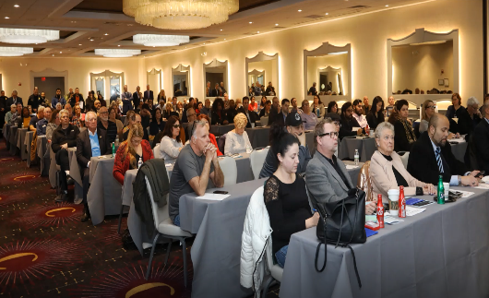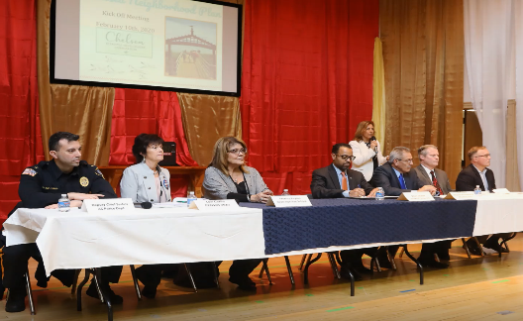
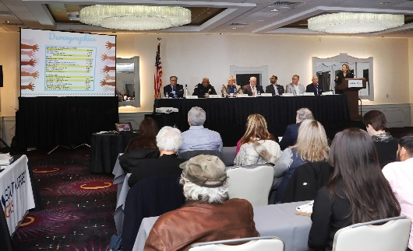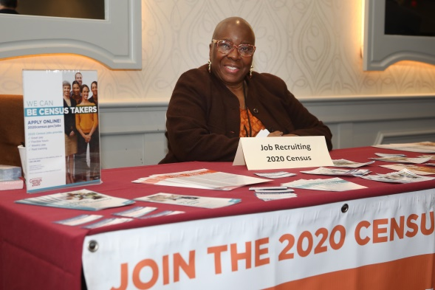

Public Officials
Before formally starting the planning process, Chelsea EDC’s President and Board Secretary met with the Mayor, Chief of Staff, and City Planning Director to introduce the organization and planned efforts. Official notice of the Plan's kick-off was given to several City departments, including the Mayor’s Office, the Business Administrator, the Clerk, City Council members, and the Department of Planning and Development in January 2020. Atlantic City’s Police Chief, Deputy Chiefs, Captains, Lieutenants, and Neighborhood and Community Outreach Officers also participated throughout the planning process, offering important insight and building connections with community members. In addition, the two Ward Councilmen who represent the Chelsea Neighborhood attended every public meeting, provided important input on several focus topics, and served as members of the Steering Committee.

Association & Community Groups
The planning process was supported by several local associations and community groups. Representatives from the Chelsea Neighborhood Association, Boys and Girls Club of Atlantic City, Hispanic Association of Atlantic County, Tropicana, Stockton University, South Jersey Gas, Sovereign Ave School, and Our Lady Star of the Sea Church have made meaningful contributions to throughout the process. Their input and continued support is essential to meeting the goals of this plan.

Internet & Social Media
Chelsea EDC’s social media platforms launched on May 18th, 2020. With a rebranding of the official website, outreach expanded with the creation of Facebook, Instagram, and Twitter pages. Chelsea EDC’s Facebook page has been the most successful in reaching the community with over 400 people regularly seeing posts. In addition, Chelsea EDC’s Constant Contact email list has expanded to more than 300 contacts.
Press releases about ACDEVCO/Chelsea EDC’s Neighborhood plan were distributed on several occasions to update the community about the process.

Direct Outreach
Prior to public meetings, the planning team printed and circulated flyers with information about when and where these meetings would occur. Flyers were translated into Vietnamese and Spanish for the community and were given to local businesses to hang up on their storefronts.
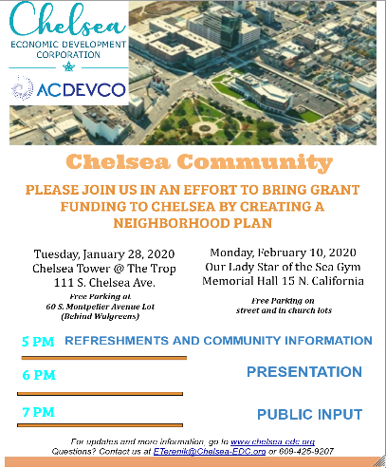
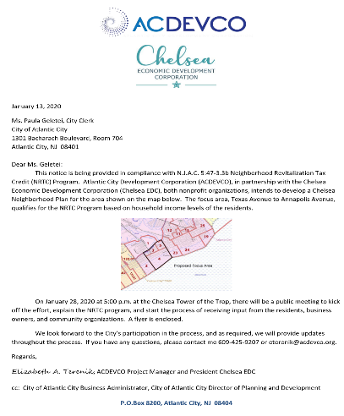
During COVID-19, ACDEVCO sponsored a food drive that was able to feed over 100 families in the Chelsea Neighborhood. Through this food drive, we had attached tags that encouraged families to visit our website and take our public survey. Through online efforts, emails had attached flyers of public meetings and were sent out to our contact list and posted on our social media. Phone calls were also made to seek participation. The steering committee also engaged in outreach by informing their respective networks. Examples of direct outreach can be found below.

Review of the Draft Plan
ACDEVCO formally provided a copy of the Chelsea Plan to the City of Atlantic City on June 1st, 2020 for their review and comment. Subsequently, on June 4th, 2020, the Planning Team held a public online Zoom meeting for the presentation of the draft Chelsea Neighborhood Plan. ACDEVCO and Chelsea EDC marketed the meeting through several social media posts, emails, and provided an RSVP option on the Chelsea EDC website to ensure a large community gathering. The meeting had more than 50 participants. After the presentation, the Planning Team took questions and noted residents’ and stakeholders’ comments. Throughout the 30 day public comment period, the ADCDEVCO/Chelsea EDC team sent reminders to the more than 300 residents and stakeholders whose emails were collected during this process. Additional outreach regarding the public comment period was done via social media and through Chelsea EDC’s website which offered a portal to submit comments.
At the conclusion of the public comment period, the Planning Team made relevant revisions to the Chelsea Neighborhood Plan suggested by the City and Neighborhood residents. The final version of the Plan was presented to the ACDEVCO and Chelsea EDC Boards of Directors.

Section 9: Attachments

https://www.brookings.edu/blog/the-avenue/2020/03/17/the-places-a-COVID-19-recession-will-likely-hit-hardest/

