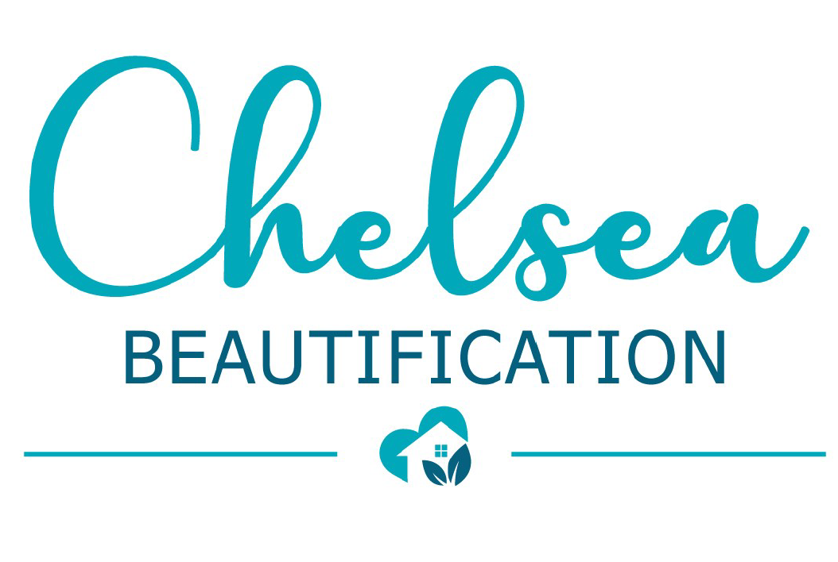
Street Captain Volunteer

Qualifications:
- Committed to positive change in the Chelsea neighborhood.
- Year around resident of area between Annapolis and Texas Avenues.
- Willingness to learn and change as needed for continual improvement of program, neighborhood, and self.
Training (to be Provided)
- How to report code violations and infrastructure issues (potholes, broken traffic lights and street signs, etc.)
- Public safety training by ACPD.
- Identifying individuals in need of social services.
- Leadership, communication, conflict resolution.
Supervision:
- Street Captains will receive support from a paid street captain coordinator.
- The project will be managed by the Chelsea Economic Development Corporation, its Board of Directors, and a Steering Committee made up of members of the community.
Duties:
- Identify and report code violations, infrastructure needs, and public safety issues.
- Recruit neighbors to improve their property and the public areas (sidewalk, street and public spaces) on your street.
- Help organize events that will build community such as block parties, neighborhood clean ups.
- Document improvements with photos and information.
- Help to educate neighbors on all aspects of the program.
- Share ideas and successes at a monthly meeting with other block captains.

Time Commitment: estimated 5 hours per week
Compensation:
- Cool Street Captain Swag
- Rewards for your street that improve the appearance and safety, determined by you and your neighbors and the Steering Committee (such as sidewalk repair, tree plantings, lighting, doorbell cameras, landscaping).
- This is not a paid position.
Send letter of interest explaining why you are interested along with resume to:
Elizabeth Terenik, President, Chelsea EDC at info@ChelseaEDC.org.

